Simple Path

Definition
# Source: AI Source: Provided by: [Data Path: Persons Table -> ID Column: 1, Name_En Column: Motasem Essam] -> From: [ChatGPT] on [7/25/2026]
A Simple Path is a geometric path that does not intersect itself during its traversal, except that a closed simple path has the same starting and ending point.
For a parameterized path $r\left(t\right)$, a simple open path satisfies:
$$\boxed{r\left(t_{1}\right)≠r\left(t_{2}\right) \text{for }t_{1}≠t_{2}}$$
For a closed path, the initial and final points may coincide:
$$\boxed{r\left(a\right)=r\left(b\right)}$$
while no other distinct parameter values produce the same point.
Simple Definition
A Simple Path is a path that does not cross or overlap itself.

Main Classification
# Source: AI Source: Provided by: [Data Path: Persons Table -> ID Column: 1, Name_En Column: Motasem Essam] -> From: [ChatGPT] on [7/25/2026]
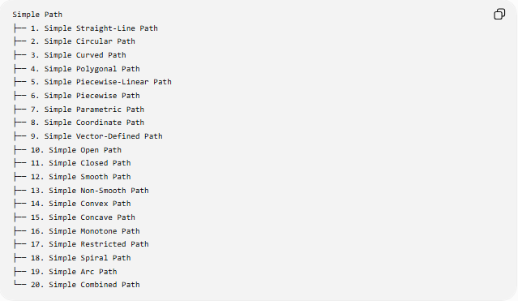
Simple Path
├── 1. Simple Straight-Line Path
├── 2. Simple Circular Path
├── 3. Simple Curved Path
├── 4. Simple Polygonal Path
├── 5. Simple Piecewise-Linear Path
├── 6. Simple Piecewise Path
├── 7. Simple Parametric Path
├── 8. Simple Coordinate Path
├── 9. Simple Vector-Defined Path
├── 10. Simple Open Path
├── 11. Simple Closed Path
├── 12. Simple Smooth Path
├── 13. Simple Non-Smooth Path
├── 14. Simple Convex Path
├── 15. Simple Concave Path
├── 16. Simple Monotone Path
├── 17. Simple Restricted Path
├── 18. Simple Spiral Path
├── 19. Simple Arc Path
└── 20. Simple Combined Path

1. Simple Straight-Line Path
# Source: AI Source: Provided by: [Data Path: Persons Table -> ID Column: 1, Name_En Column: Motasem Essam] -> From: [ChatGPT] on [7/25/2026]
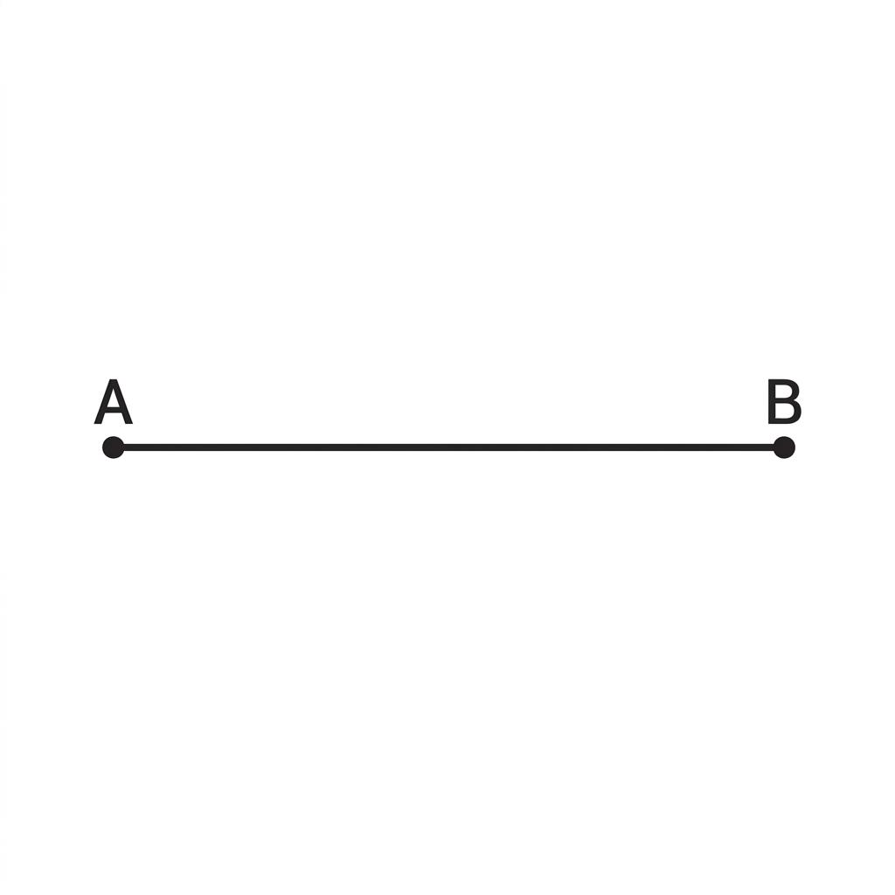
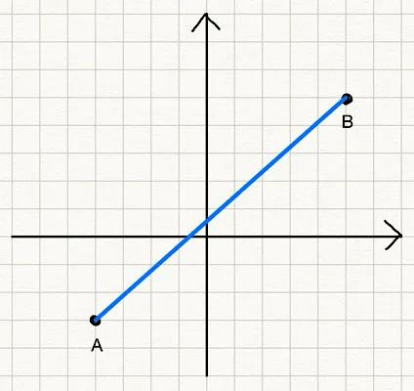
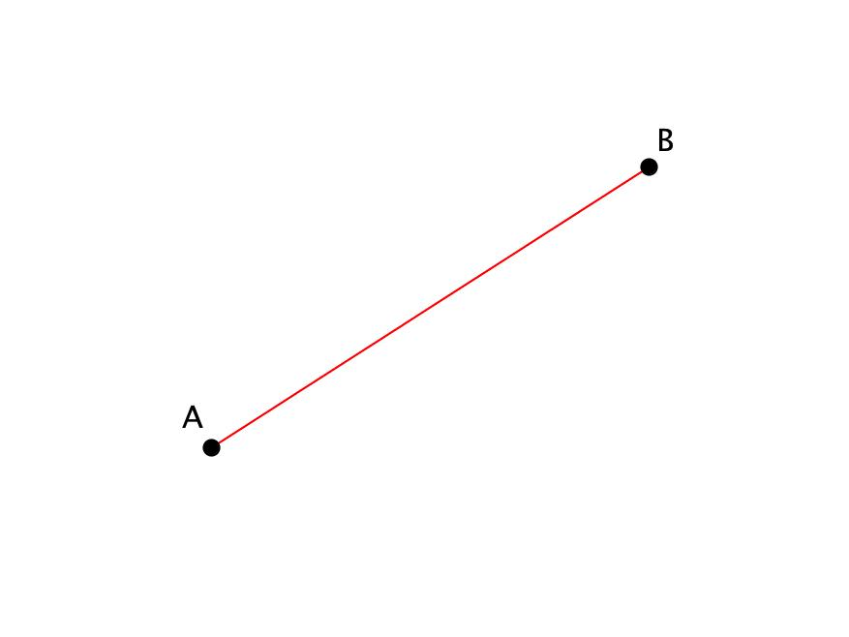
A Simple Straight-Line Path consists of a straight segment that does not intersect itself.
For two distinct points $A$and $B$:
$$\boxed{P=\overset{‾}{AB}}$$
The path has no self-intersection.
Example
A path from:
$$A=\left(0 , 0\right)$$
to:
$$B=\left(5 , 3\right)$$
along the segment $\overset{‾}{AB}$is a simple path.
Its length is:
$$L=\sqrt{{\left(5-0\right)}^{2}+{\left(3-0\right)}^{2}}=\sqrt{34}$$

4. Simple Circular Path
A Simple Circular Path follows a circle without crossing itself.
A complete circle is a simple closed path:
$$\boxed{{\left(x-h\right)}^{2}+{\left(y-k\right)}^{2}=r^{2}}$$
Although the path returns to its starting point, it does not cross itself elsewhere.
Example
A circle centered at the origin:
$$x^{2}+y^{2}=25$$
is a simple closed path.
Its radius is:
$$r=5$$
and its circumference is:
$$L=2πr=10π$$

2. Simple Curved Path
# Source: AI Source: Provided by: [Data Path: Persons Table -> ID Column: 1, Name_En Column: Motasem Essam] -> From: [ChatGPT] on [7/25/2026]
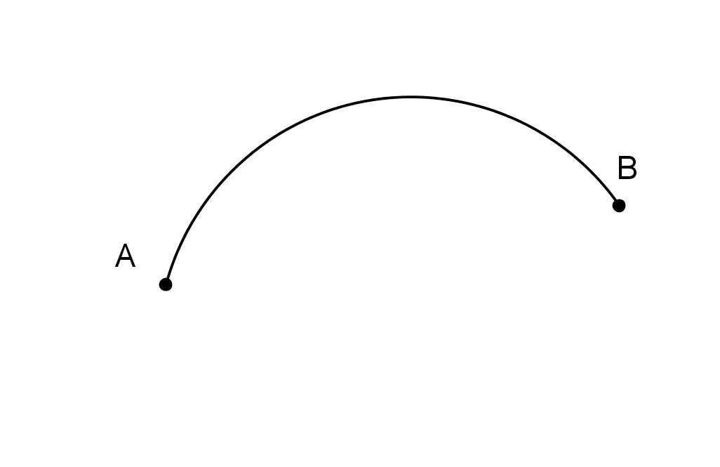
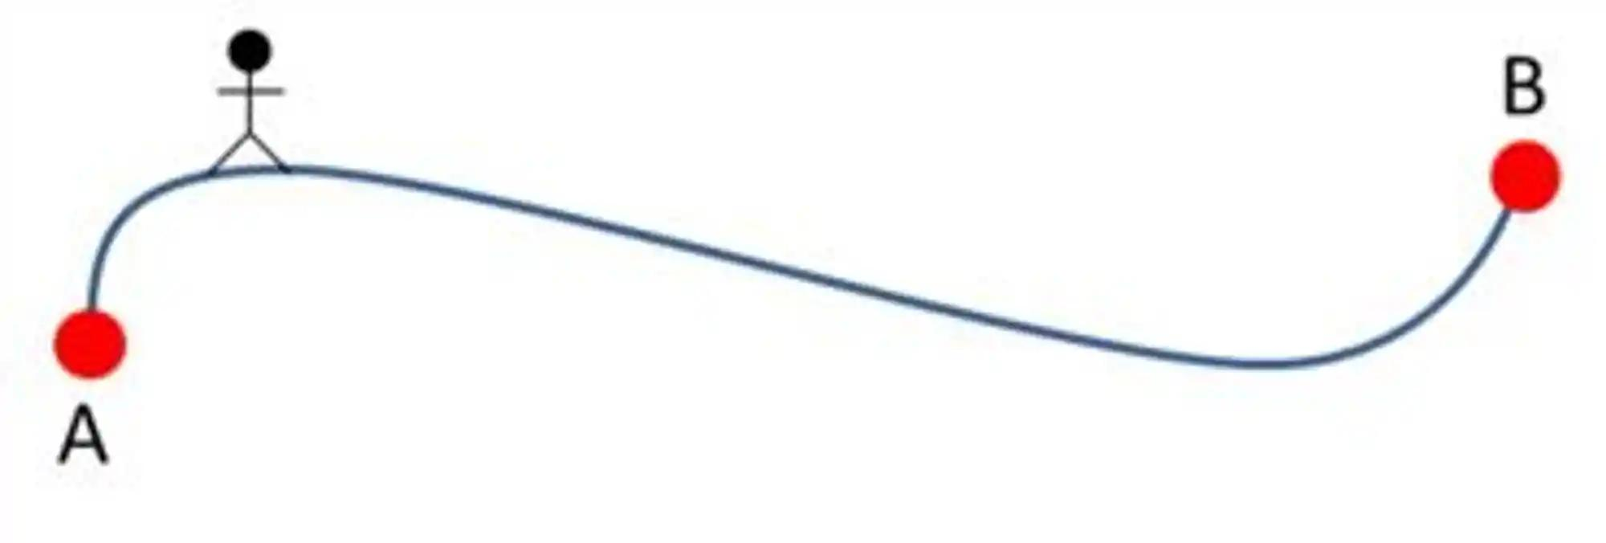
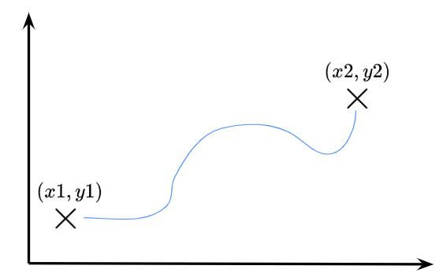
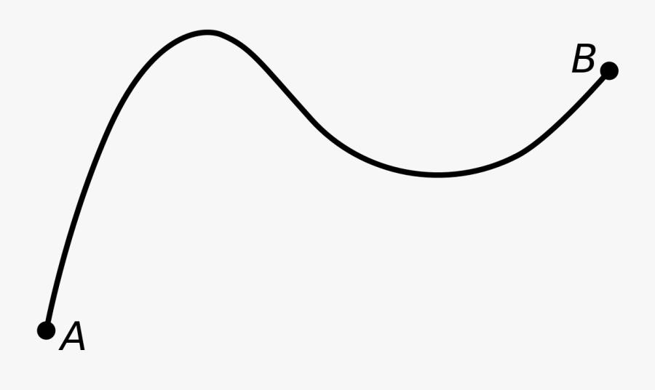
A Simple Curved Path is a curved path that does not intersect itself.
It can have many different shapes, such as parabolic, elliptical, or other curves.
Example
Consider:
$$y=x^{2}, 0≤x≤3$$
This portion of the parabola does not cross itself, so it is a simple curved path.

3. Simple Polygonal Path
# Source: AI Source: Provided by: [Data Path: Persons Table -> ID Column: 1, Name_En Column: Motasem Essam] -> From: [ChatGPT] on [7/25/2026]
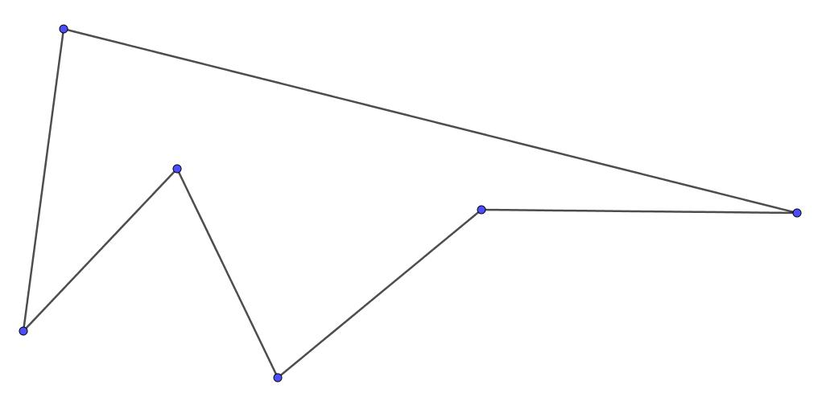
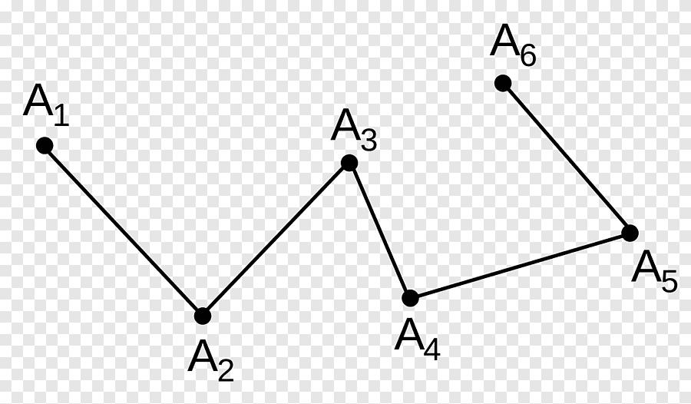
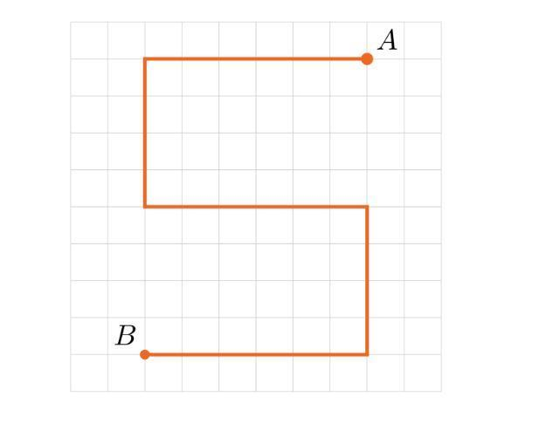
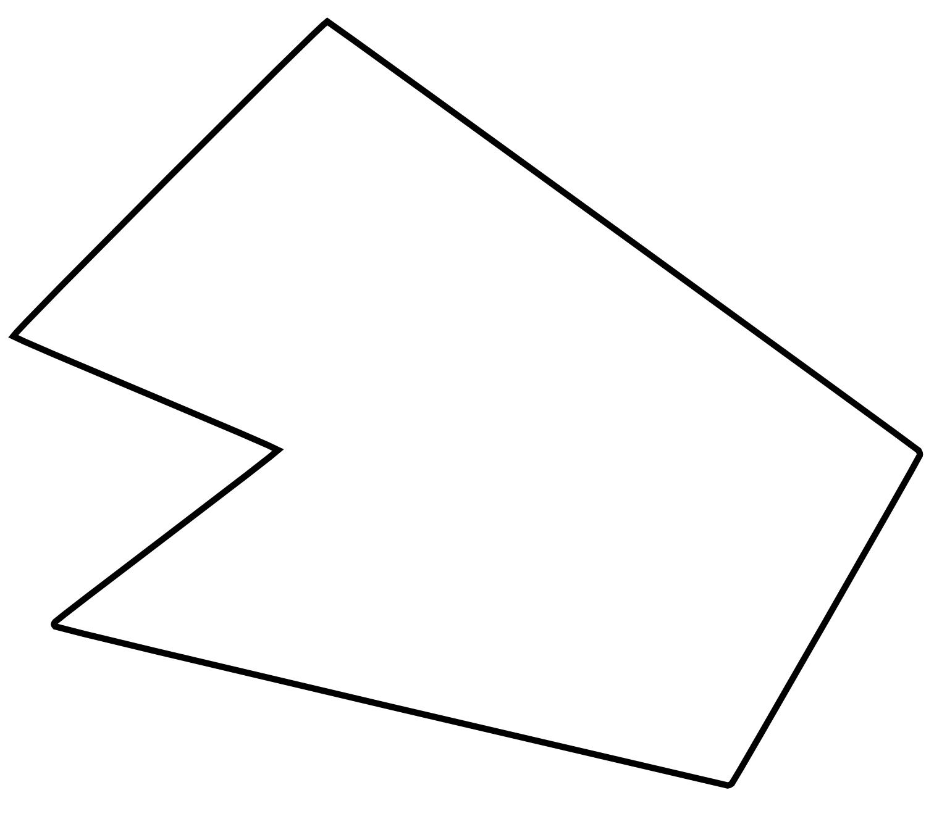
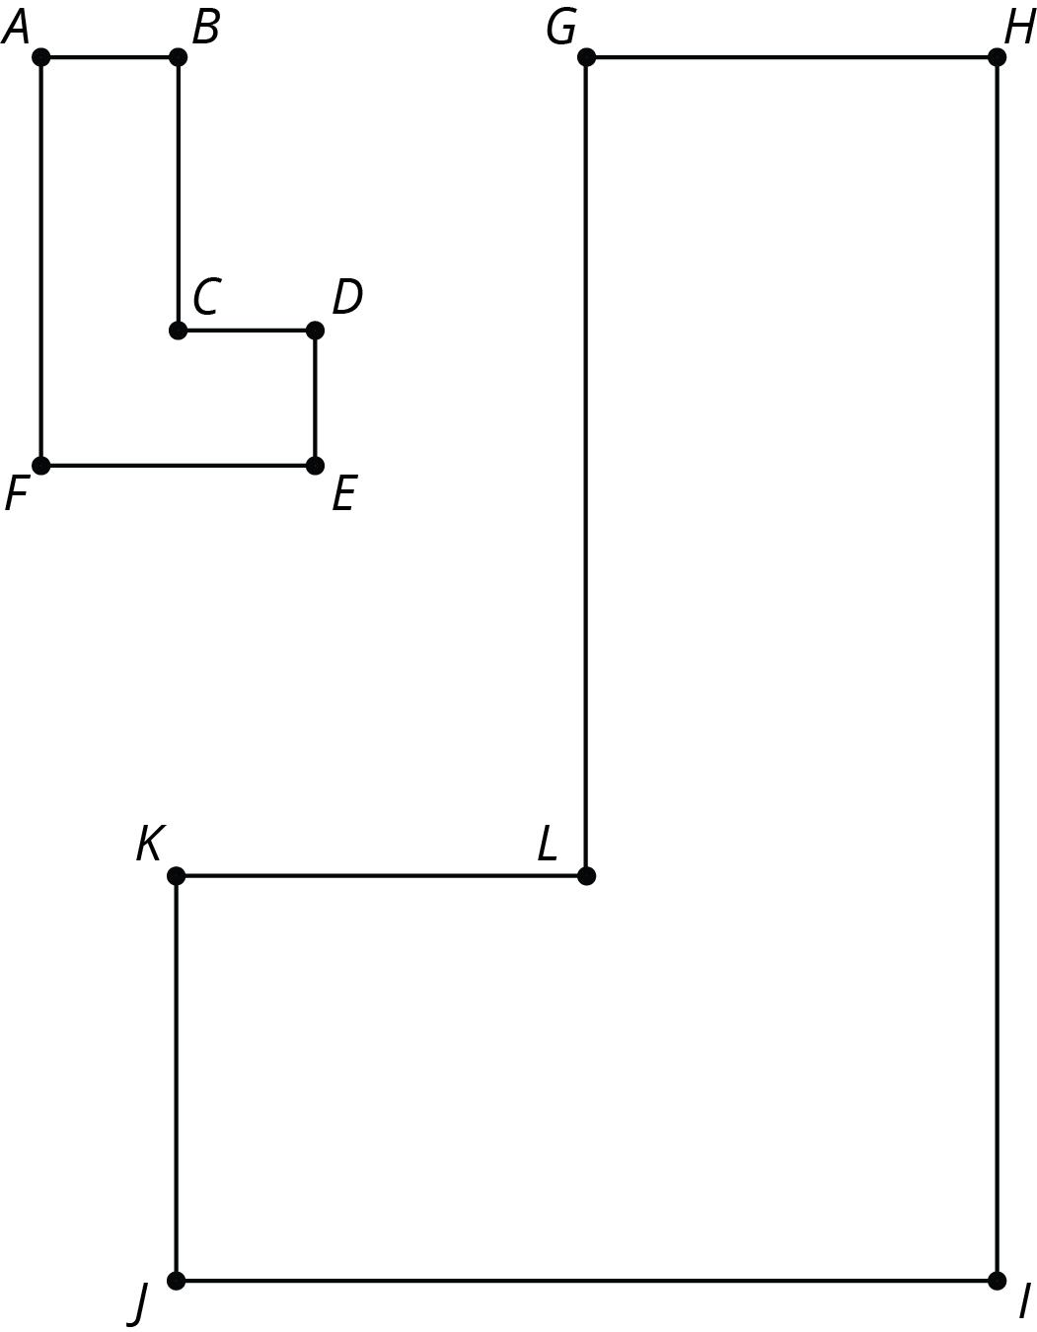
A Simple Polygonal Path consists of connected straight-line segments where nonconsecutive segments do not intersect.
For vertices
$$P_{0},P_{1},…,P_{n}$$
the path is:
$$P=\overset{‾}{P_{0}P_{1}}∪\overset{‾}{P_{1}P_{2}}∪⋯∪\overset{‾}{P_{n-1}P_{n}}$$
with no self-crossings.
Example
$$A→B→C→D$$
forming a non-crossing route is a simple polygonal path.
A triangle boundary is also a simple closed polygonal path.

4. Simple Piecewise-Linear Path
# Source: AI Source: Provided by: [Data Path: Persons Table -> ID Column: 1, Name_En Column: Motasem Essam] -> From: [ChatGPT] on [7/25/2026]
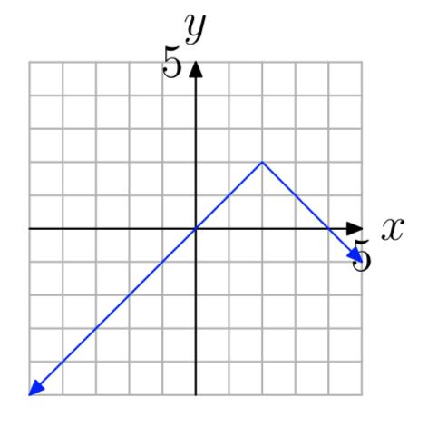
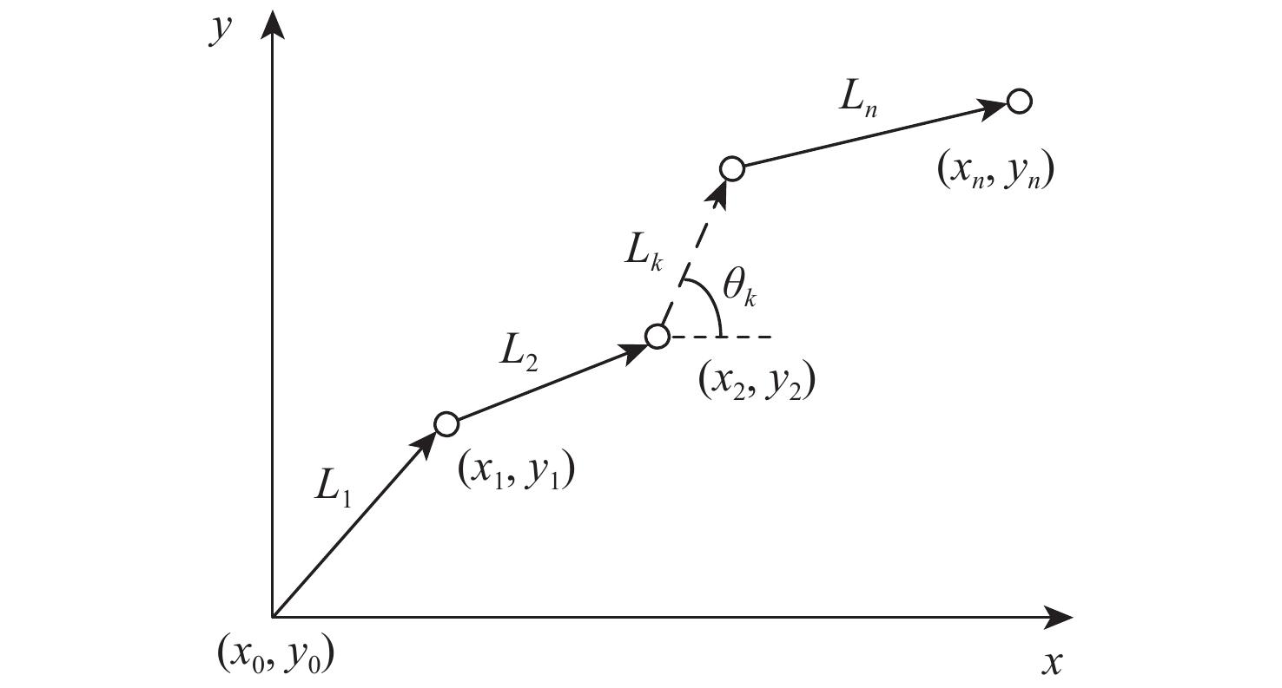
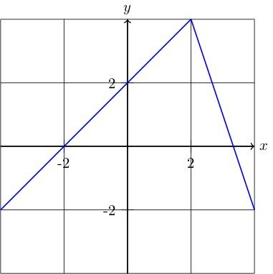
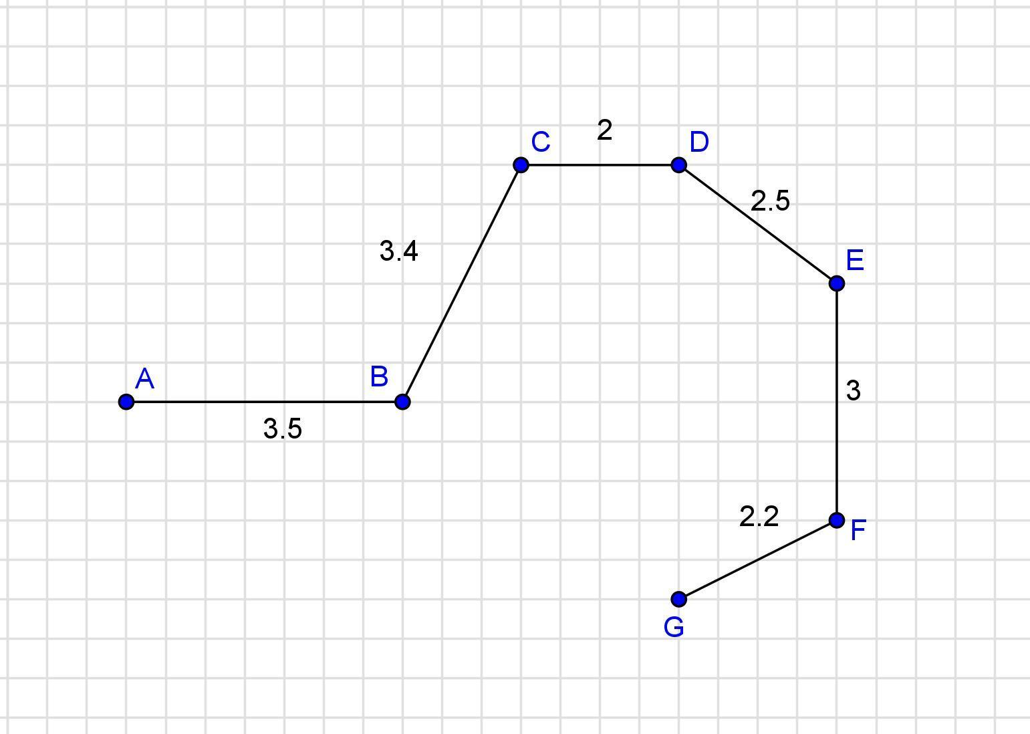
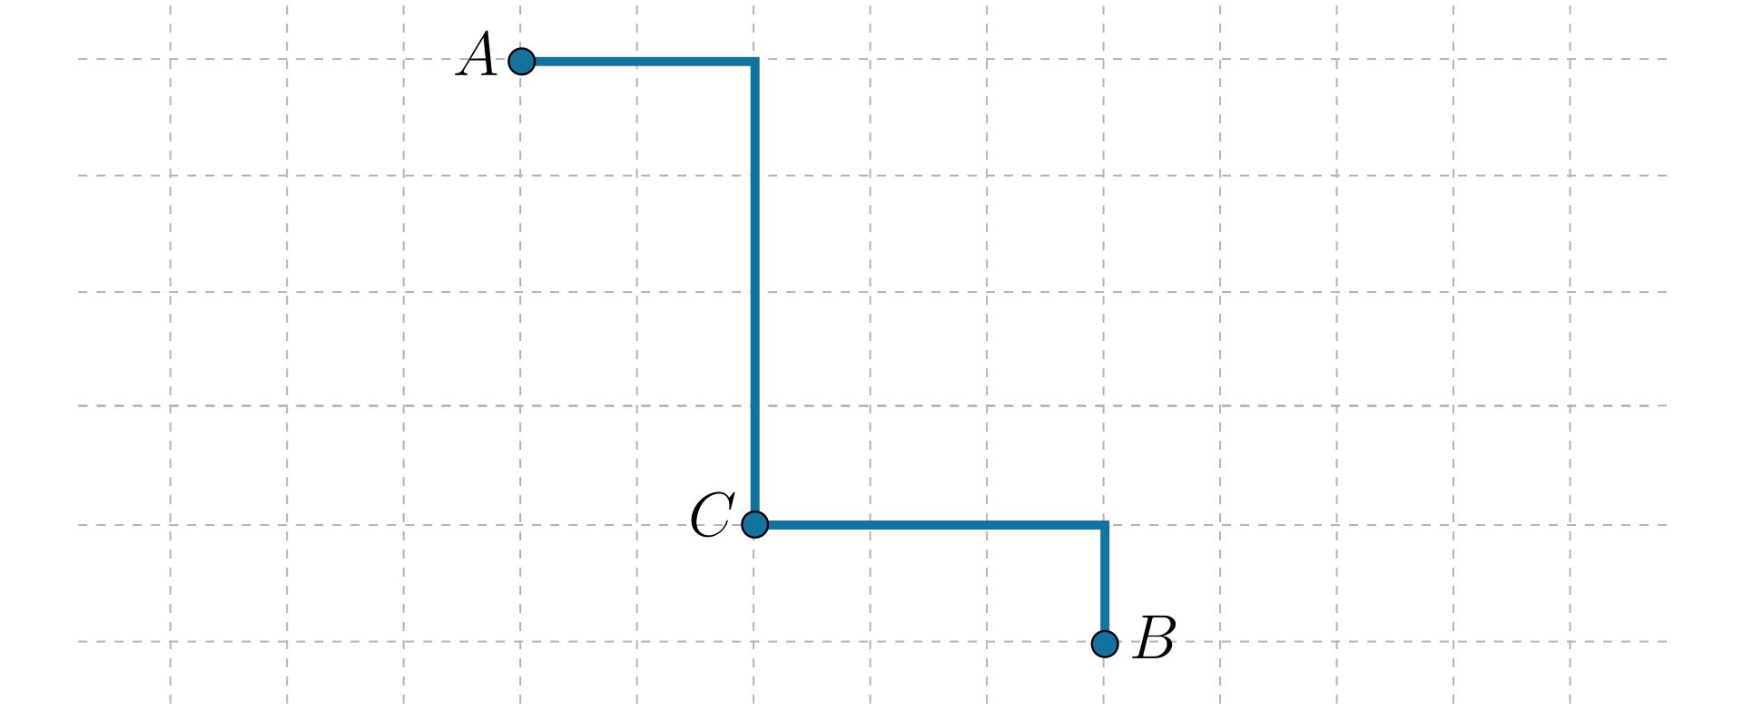
A Simple Piecewise-Linear Path consists of multiple connected straight-line pieces without self-intersection.
It is essentially a simple polygonal path.
Example
$$A→B→C→D$$
where the segments meet only at consecutive vertices.
Important relationship:
$$\boxed{\text{Simple Piecewise-Linear Path}≈\text{Simple Polygonal Path}}$$

5. Simple Piecewise Path
# Source: AI Source: Provided by: [Data Path: Persons Table -> ID Column: 1, Name_En Column: Motasem Essam] -> From: [ChatGPT] on [7/25/2026]
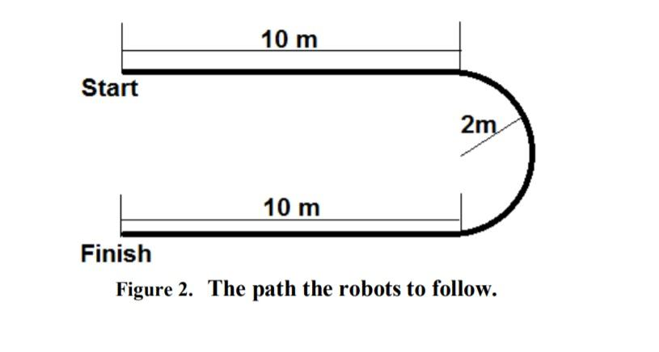
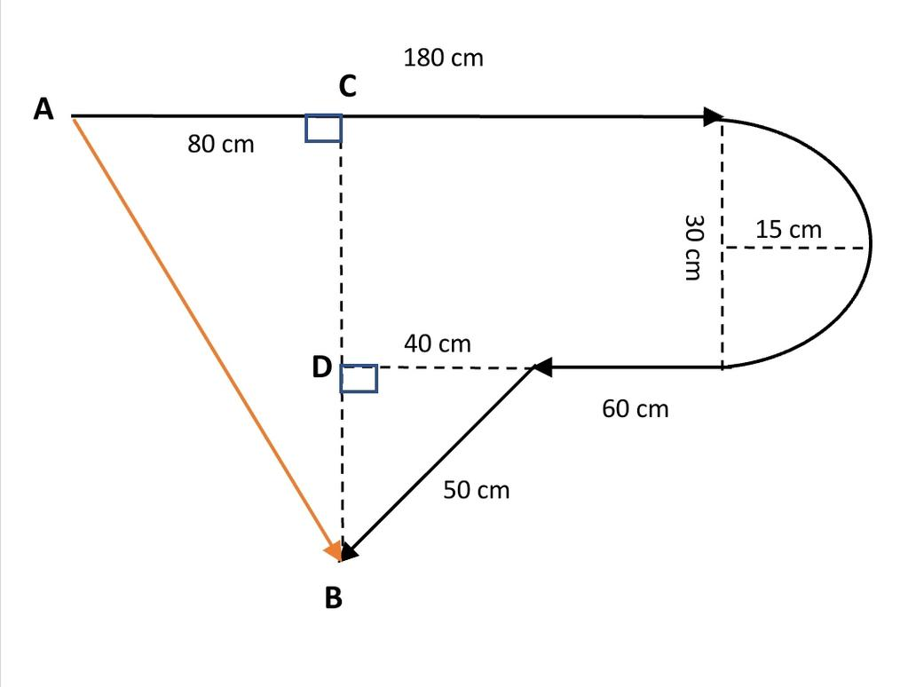
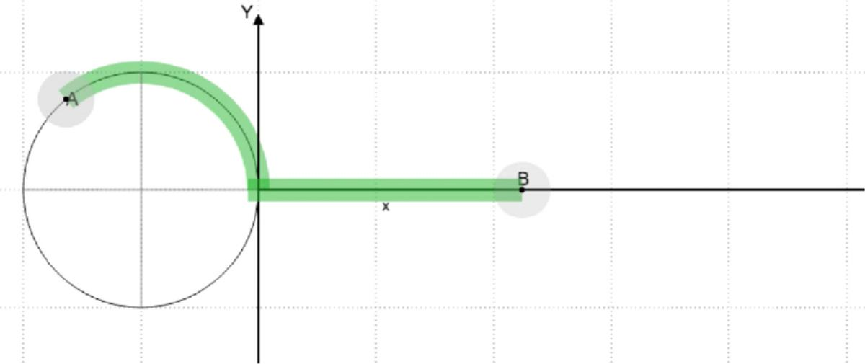
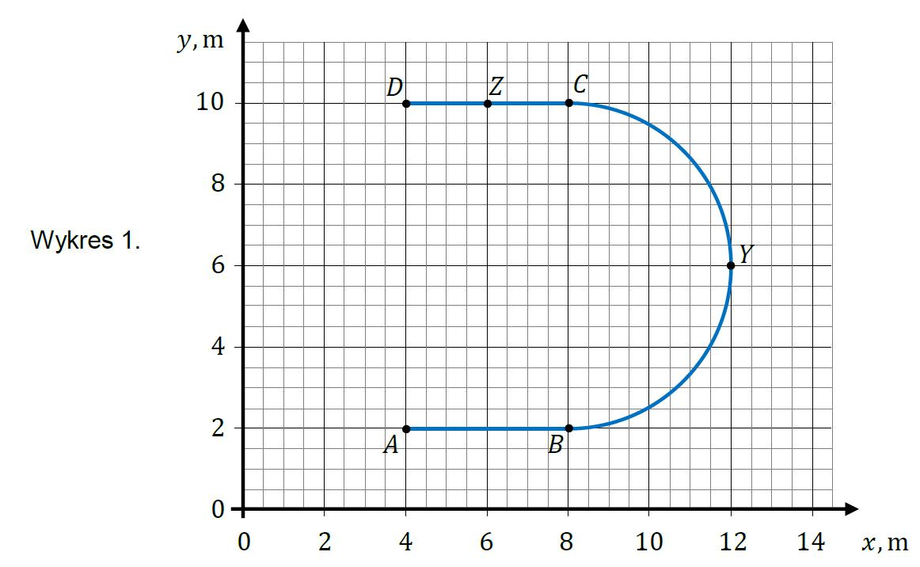
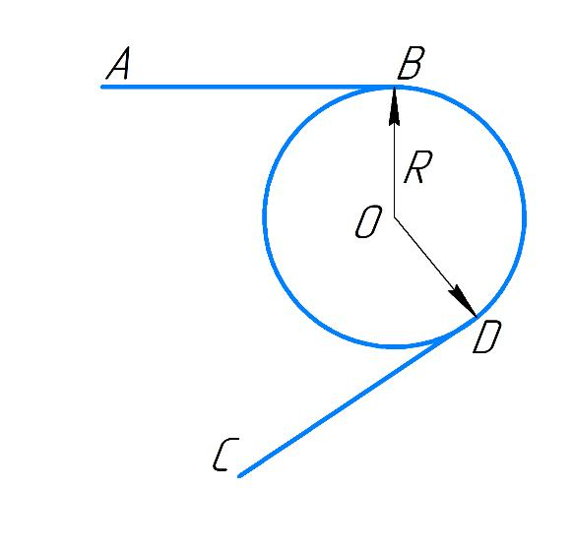
A Simple Piecewise Path consists of multiple geometric pieces that collectively do not intersect themselves.
The pieces can include:
- straight segments
- circular arcs
- parabolic pieces
- other curves
Example
$$\text{Straight Segment}→\text{Circular Arc}→\text{Straight Segment}$$
If none of the pieces cross another nonadjacent piece, the overall path is simple.

6. Simple Parametric Path
# Source: AI Source: Provided by: [Data Path: Persons Table -> ID Column: 1, Name_En Column: Motasem Essam] -> From: [ChatGPT] on [7/25/2026]
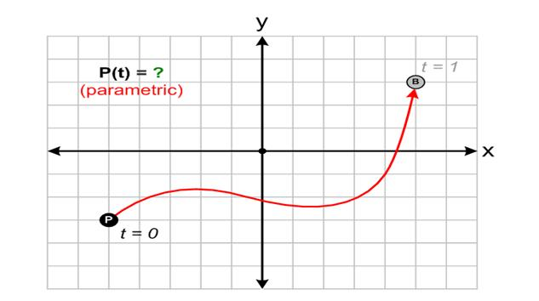
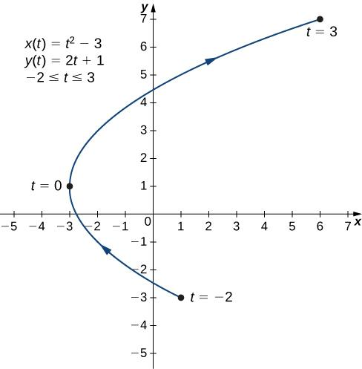
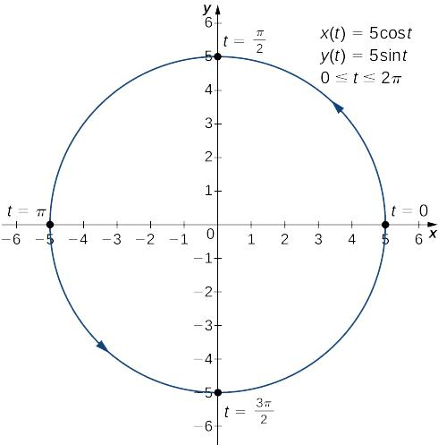
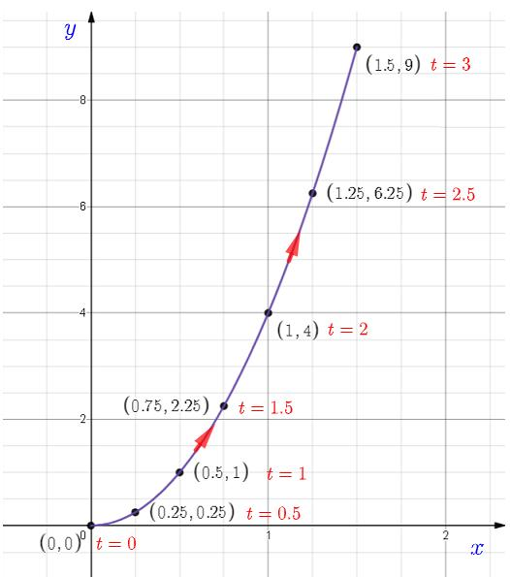
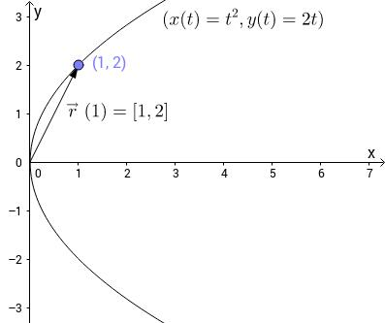
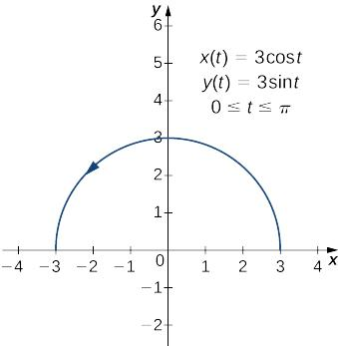
A Simple Parametric Path is represented parametrically and does not repeat a point for distinct parameter values, except for the permitted initial/final coincidence of a closed path.
$$r\left(t\right)=\left\langle x , \left(t\right)y\left(t\right)\right\rangle$$
For an open simple path:
$$\boxed{r\left(t_{1}\right)≠r\left(t_{2}\right) \left(t_{1}≠t_{2}\right)}$$
Example
$$r\left(t\right)=\left\langle t , t^{2}\right\rangle , 0≤t≤2$$
This traces:
$$y=x^{2}$$
without self-intersection.

7. Simple Coordinate Path
# Source: AI Source: Provided by: [Data Path: Persons Table -> ID Column: 1, Name_En Column: Motasem Essam] -> From: [ChatGPT] on [7/25/2026]
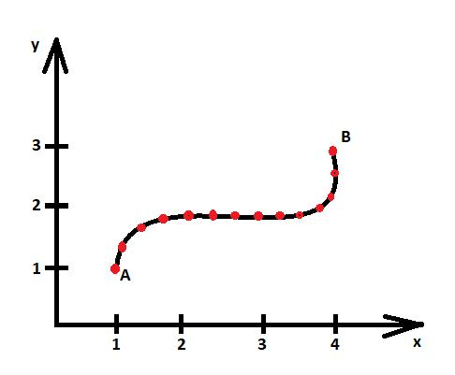
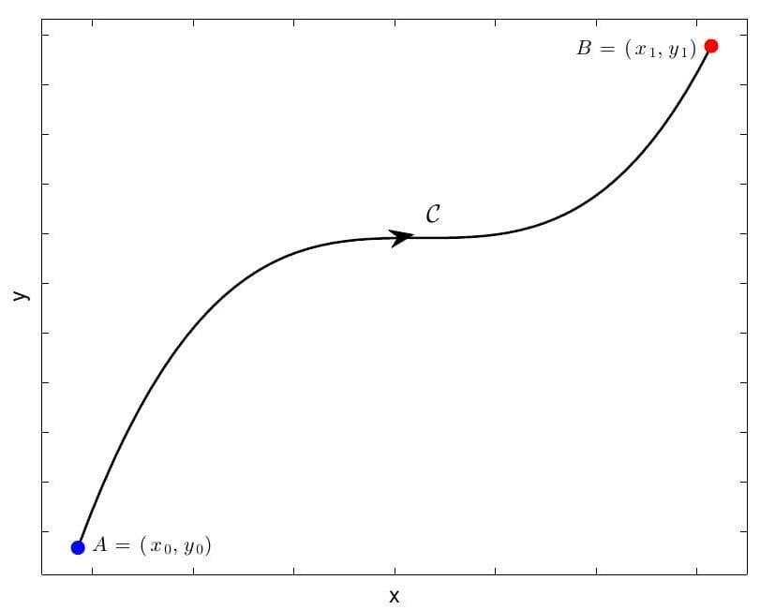
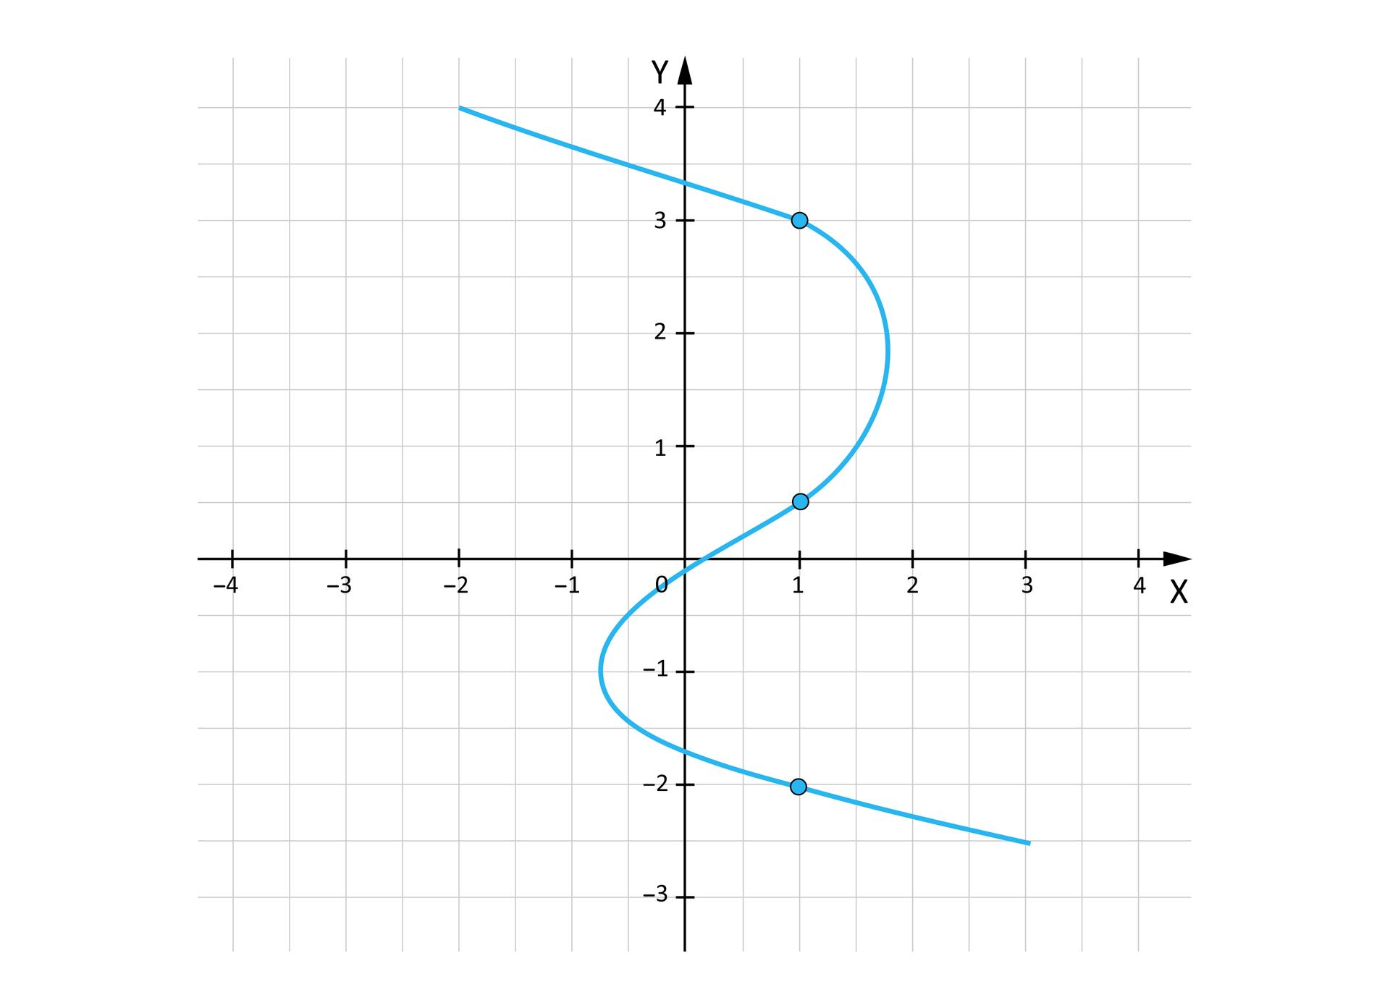
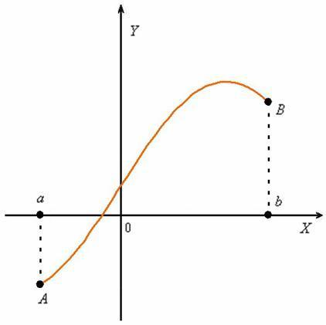
A Simple Coordinate Path is a path described using coordinate equations that does not cross itself.
Example
$$y=x^{2}, -2≤x≤2$$
is simple because each $x$-value corresponds to exactly one point on this restricted path, and the path does not cross itself.

8. Simple Vector-Defined Path
# Source: AI Source: Provided by: [Data Path: Persons Table -> ID Column: 1, Name_En Column: Motasem Essam] -> From: [ChatGPT] on [7/25/2026]
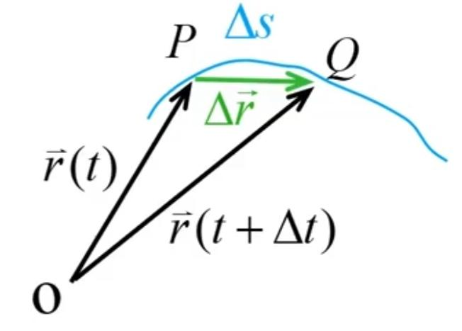
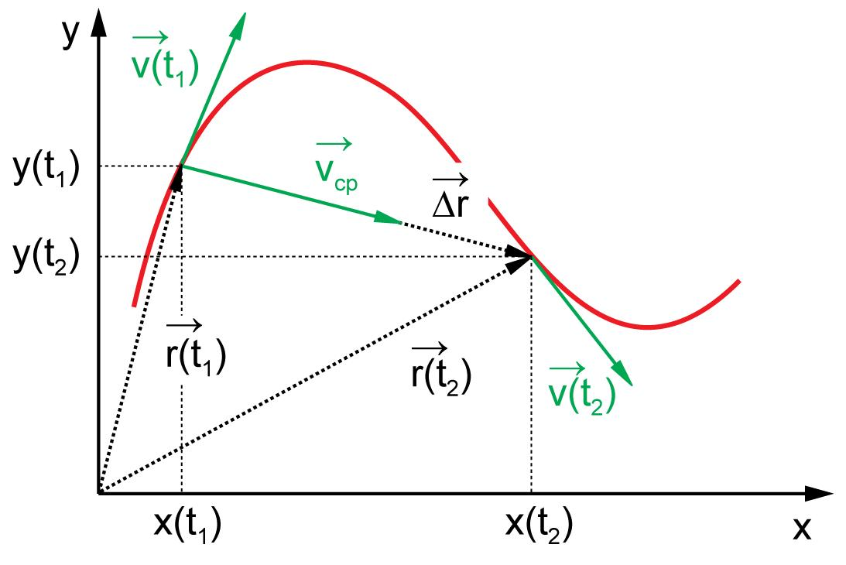
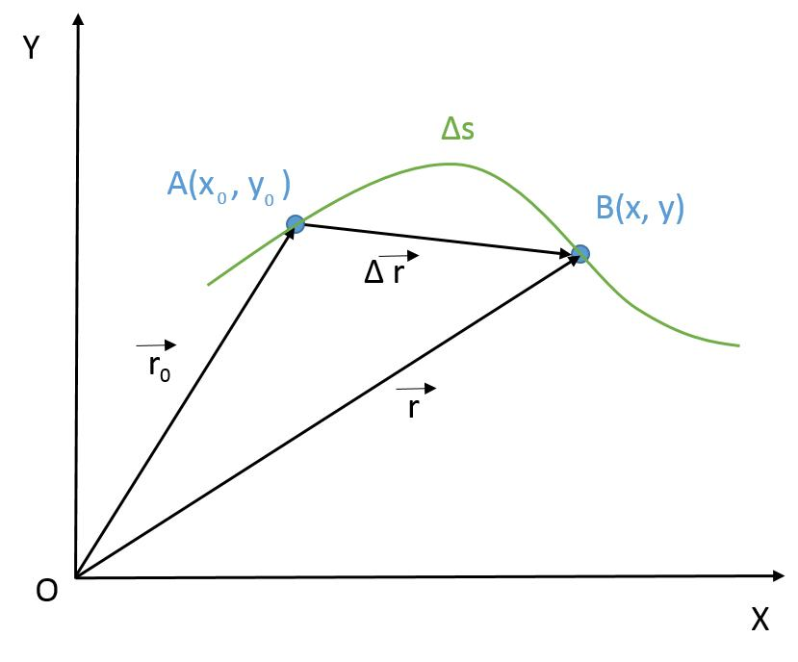
A Simple Vector-Defined Path uses a vector-valued function and does not revisit points during its traversal, except for the start/end point of a closed path.
$$\boxed{r\left(t\right)=r_{0}+tv}$$
is an example of a simple straight path.
Example
$$r\left(t\right)=\left\langle 1 , 2\right\rangle +t\left\langle 3 , 1\right\rangle , 0≤t≤1$$
moves from:
$$\left(1 , 2\right)$$
to:
$$\left(4 , 3\right)$$
without self-intersection.

9. Simple Open Path
# Source: AI Source: Provided by: [Data Path: Persons Table -> ID Column: 1, Name_En Column: Motasem Essam] -> From: [ChatGPT] on [7/25/2026]
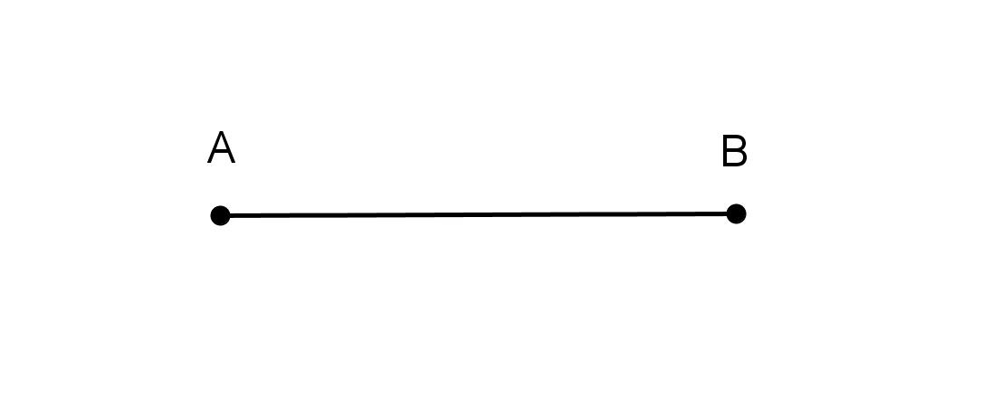
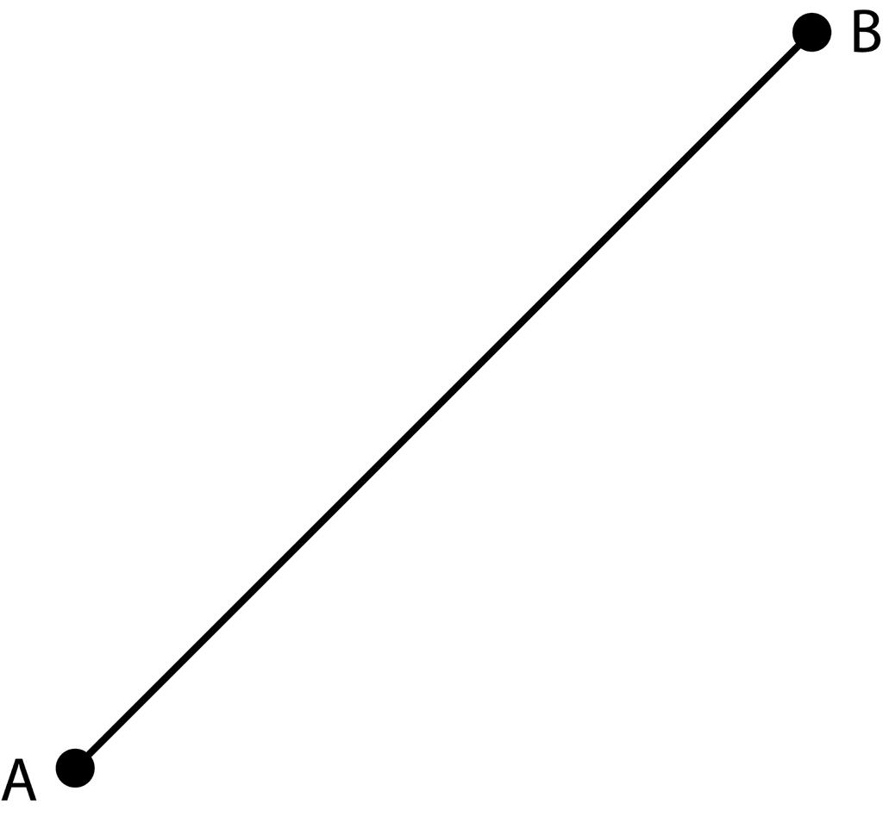
A Simple Open Path has:
- different starting and ending points, and
- no self-intersection.
$$\boxed{P_{\text{start}}≠P_{\text{end}}}$$
and:
$$\boxed{\text{No self-intersections}}$$
Example
A curved path from $A$to $B$that never crosses itself is a simple open path.

10. Simple Closed Path
# Source: AI Source: Provided by: [Data Path: Persons Table -> ID Column: 1, Name_En Column: Motasem Essam] -> From: [ChatGPT] on [7/25/2026]
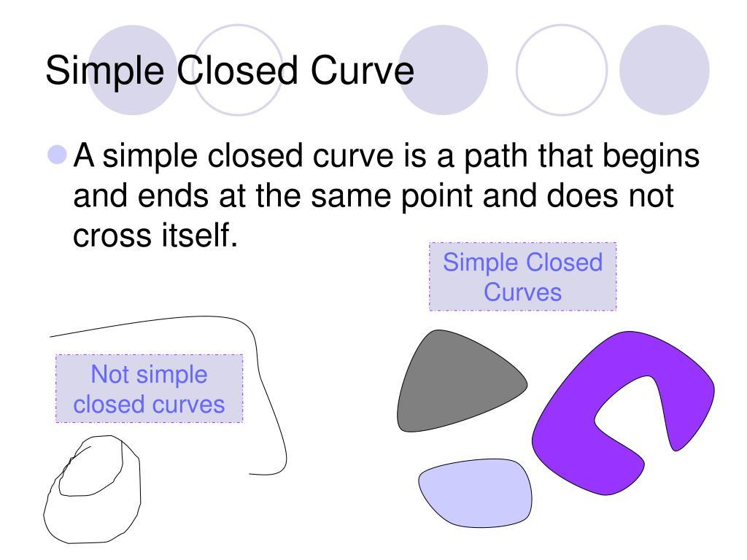
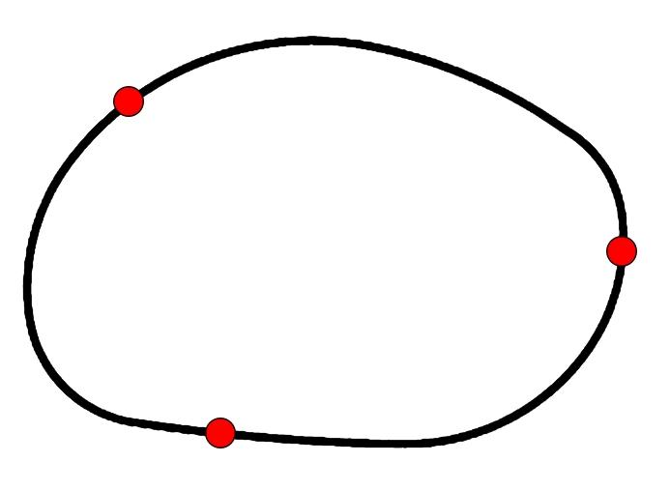
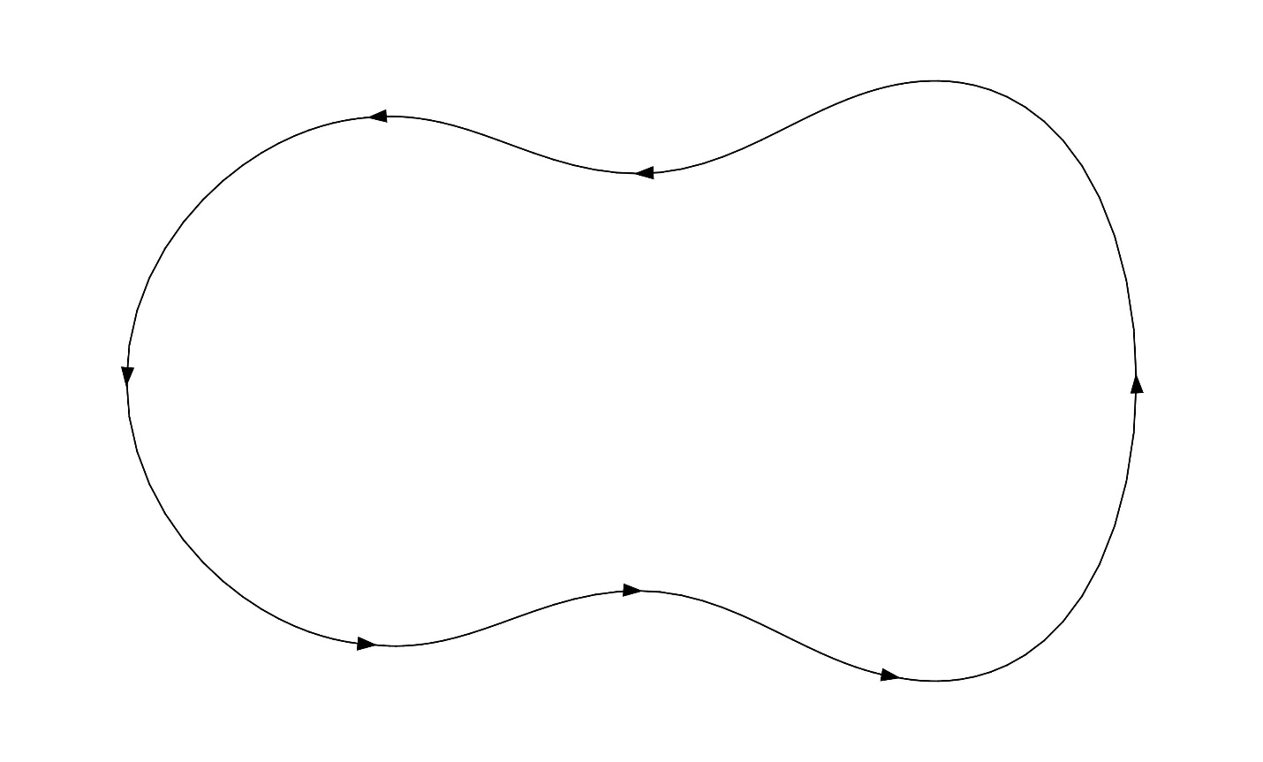
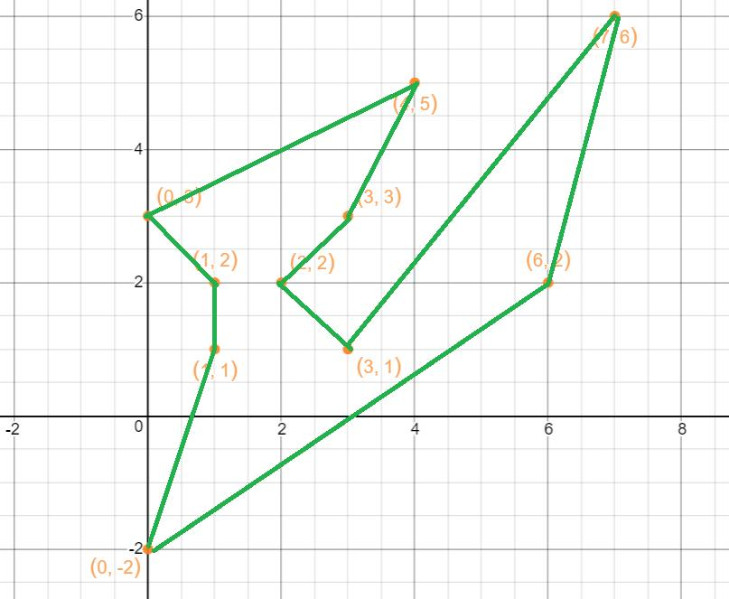
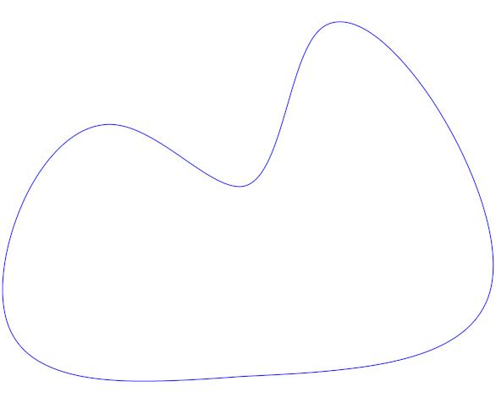
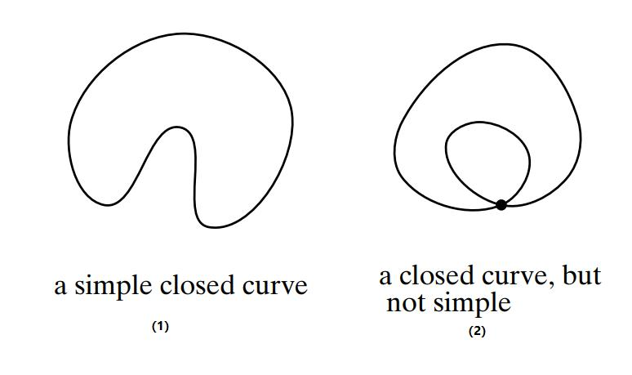
A Simple Closed Path returns to its starting point but does not intersect itself anywhere else.
$$\boxed{P_{\text{start}}=P_{\text{end}}}$$
with no other self-intersections.
Examples
- circle
- ellipse
- triangle boundary
- square boundary
- simple convex polygon
A simple closed path can form the boundary of a planar region.

11. Simple Smooth Path
# Source: AI Source: Provided by: [Data Path: Persons Table -> ID Column: 1, Name_En Column: Motasem Essam] -> From: [ChatGPT] on [7/25/2026]
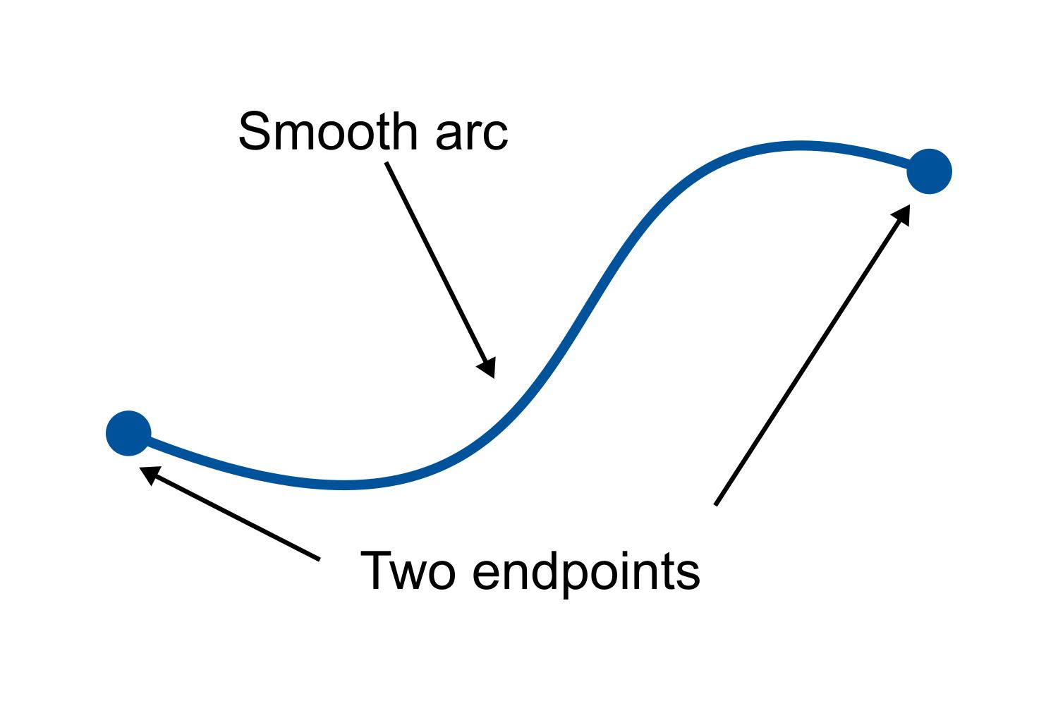
A Simple Smooth Path is both:
- simple, and
- smooth.
It has no self-intersections and no sharp corners.
For a parameterized path:
$$r\left(t\right)=\left\langle x , \left(t\right)y\left(t\right)\right\rangle$$
the tangent direction changes continuously.
Example
An ellipse:
$$\frac{x^{2}}{a^{2}}+\frac{y^{2}}{b^{2}}=1$$
is a simple smooth closed path.

12. Simple Non-Smooth Path
# Source: AI Source: Provided by: [Data Path: Persons Table -> ID Column: 1, Name_En Column: Motasem Essam] -> From: [ChatGPT] on [7/25/2026]
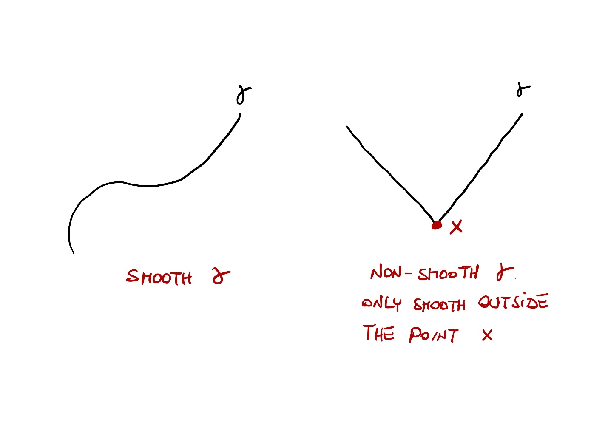
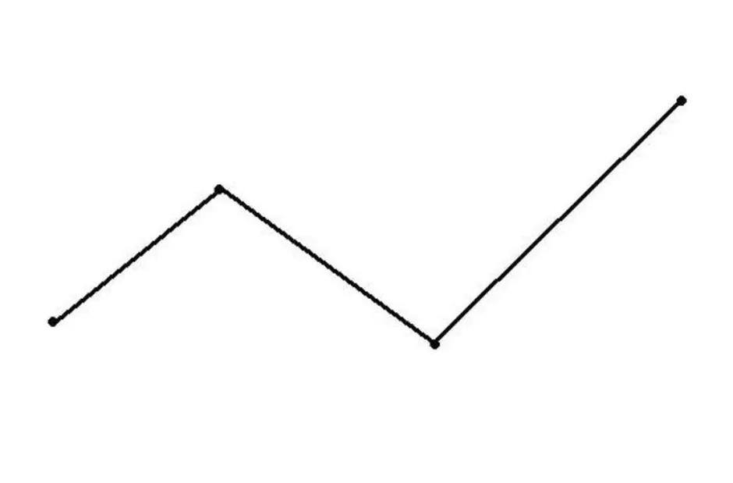
A Simple Non-Smooth Path has no self-intersections but contains one or more sharp corners or non-smooth points.
Example
A square boundary is simple but non-smooth at its four vertices.
Thus:
$$\boxed{\text{Simple}⇏\text{Smooth}}$$

13. Simple Convex Path
# Source: AI Source: Provided by: [Data Path: Persons Table -> ID Column: 1, Name_En Column: Motasem Essam] -> From: [ChatGPT] on [7/25/2026]
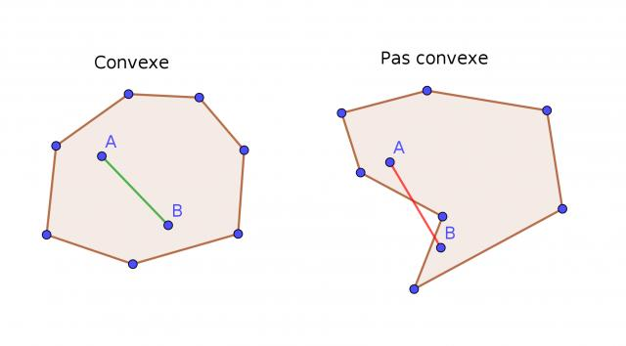
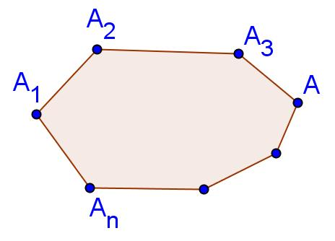
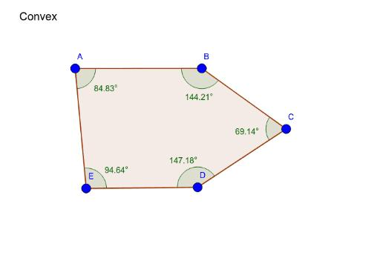
A Simple Convex Path is a simple closed path whose enclosed region is convex.
For any two points $A$and $B$inside or on the boundary of the region, the entire segment $\overset{‾}{AB}$remains inside the region.
Examples
- circle
- ellipse
- square
- regular polygon
A circle is both simple and convex.

14. Simple Concave Path
# Source: AI Source: Provided by: [Data Path: Persons Table -> ID Column: 1, Name_En Column: Motasem Essam] -> From: [ChatGPT] on [7/25/2026]
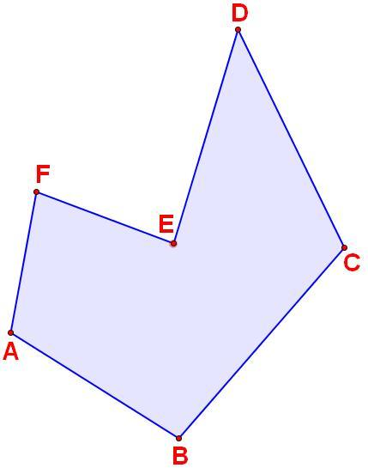
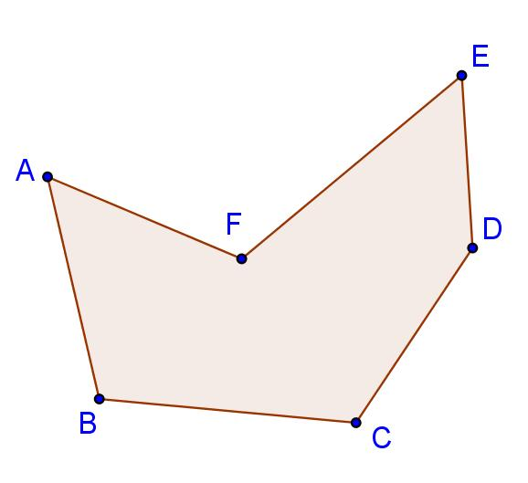
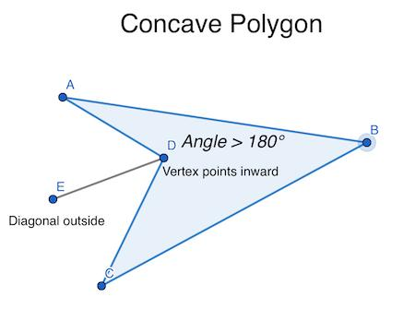
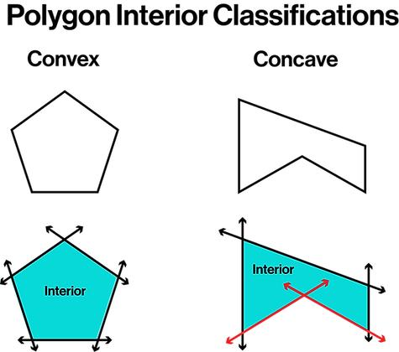
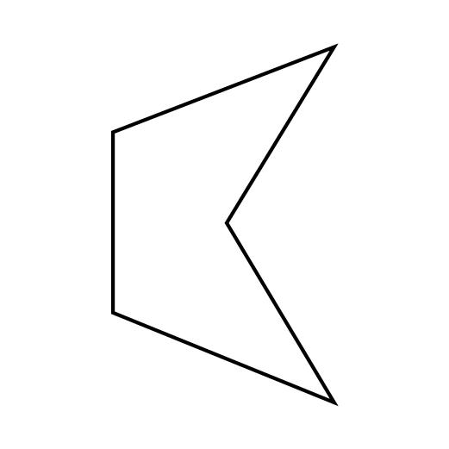
A Simple Concave Path is a simple closed path enclosing a non-convex region.
It does not cross itself, but the enclosed region contains at least one inward indentation.
Example
An arrow-shaped polygon can be simple and concave.
Therefore:
$$\boxed{\text{Simple}⇏\text{Convex}}$$
A path can be simple while being concave.

15. Simple Monotone Path
# Source: AI Source: Provided by: [Data Path: Persons Table -> ID Column: 1, Name_En Column: Motasem Essam] -> From: [ChatGPT] on [7/25/2026]
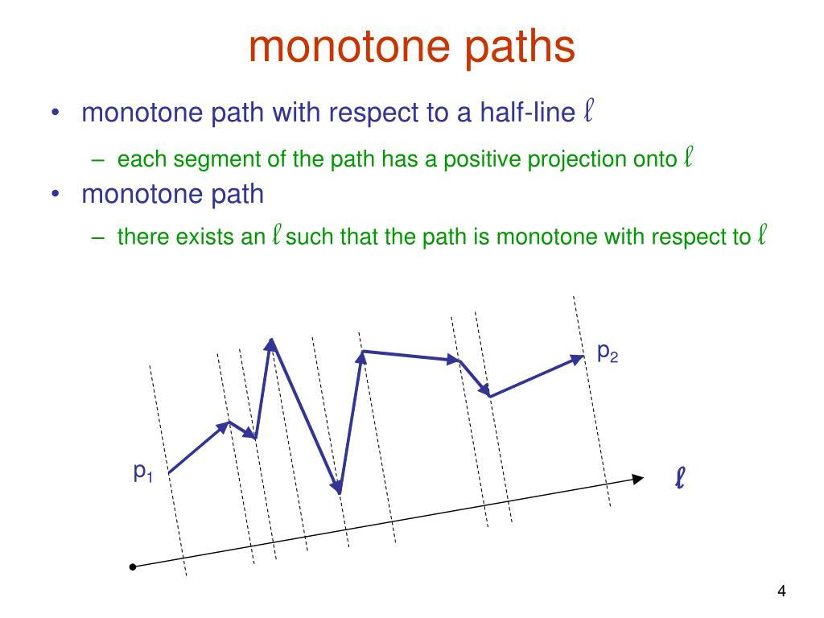
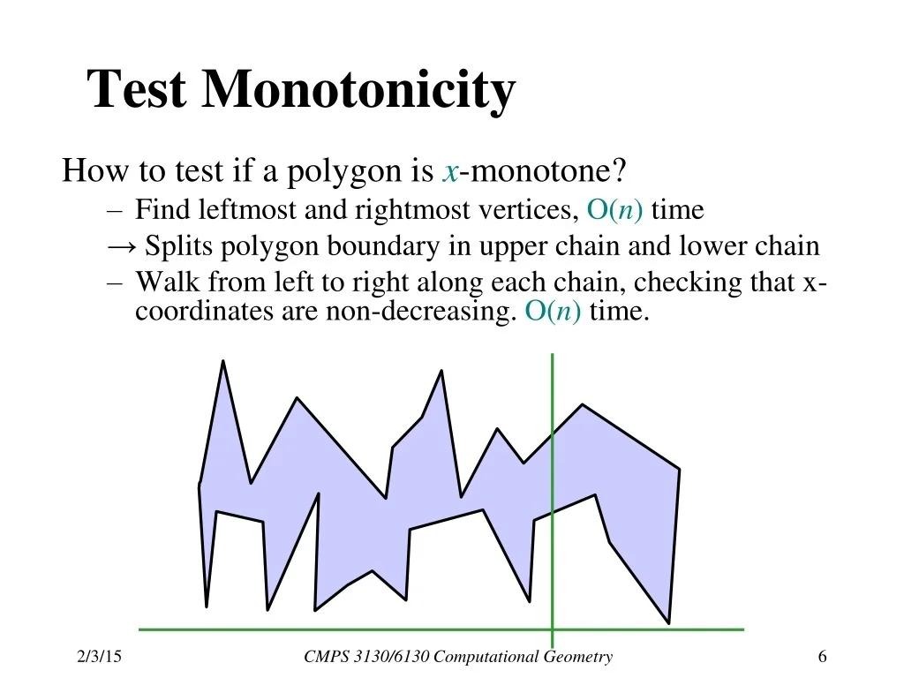
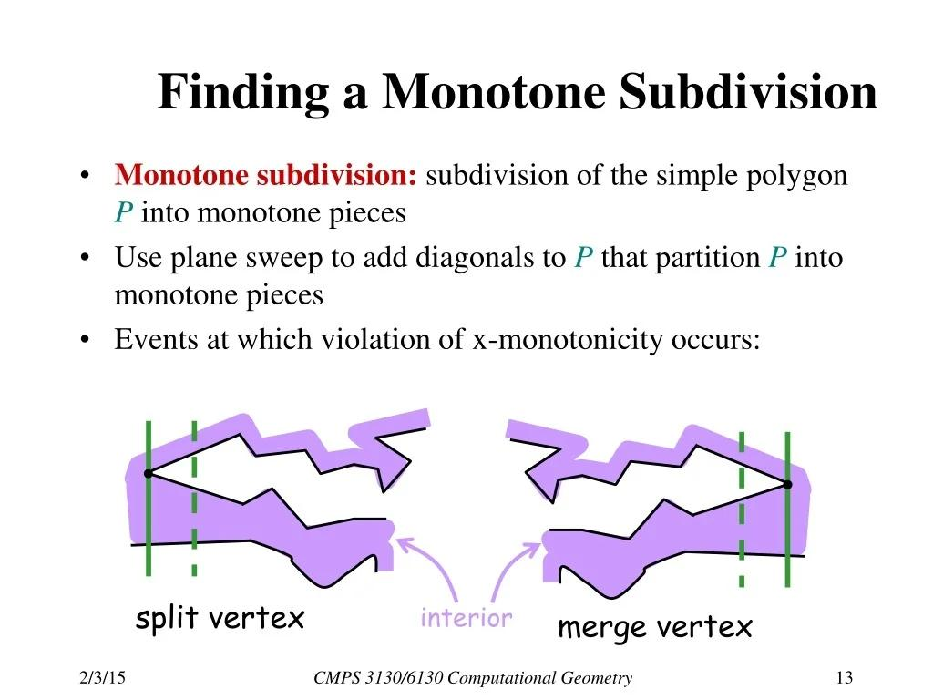
A Simple Monotone Path progresses consistently in a specified coordinate direction without reversing in that direction.
For example, an $x$-monotone path generally moves from left to right without backtracking in $x$.
Example
$$y=x^{2}, 0≤x≤4$$
is $x$-monotone because $x$continuously increases from $0$to $4$.

16. Simple Restricted Path
# Source: AI Source: Provided by: [Data Path: Persons Table -> ID Column: 1, Name_En Column: Motasem Essam] -> From: [ChatGPT] on [7/25/2026]
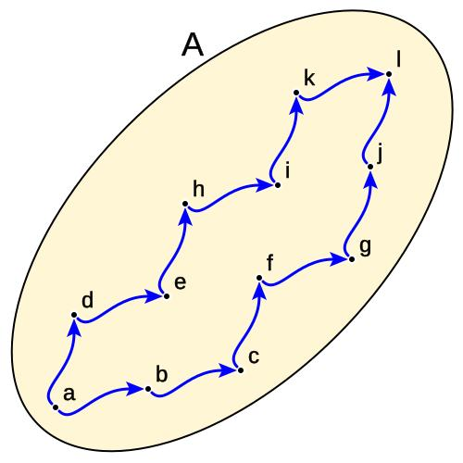
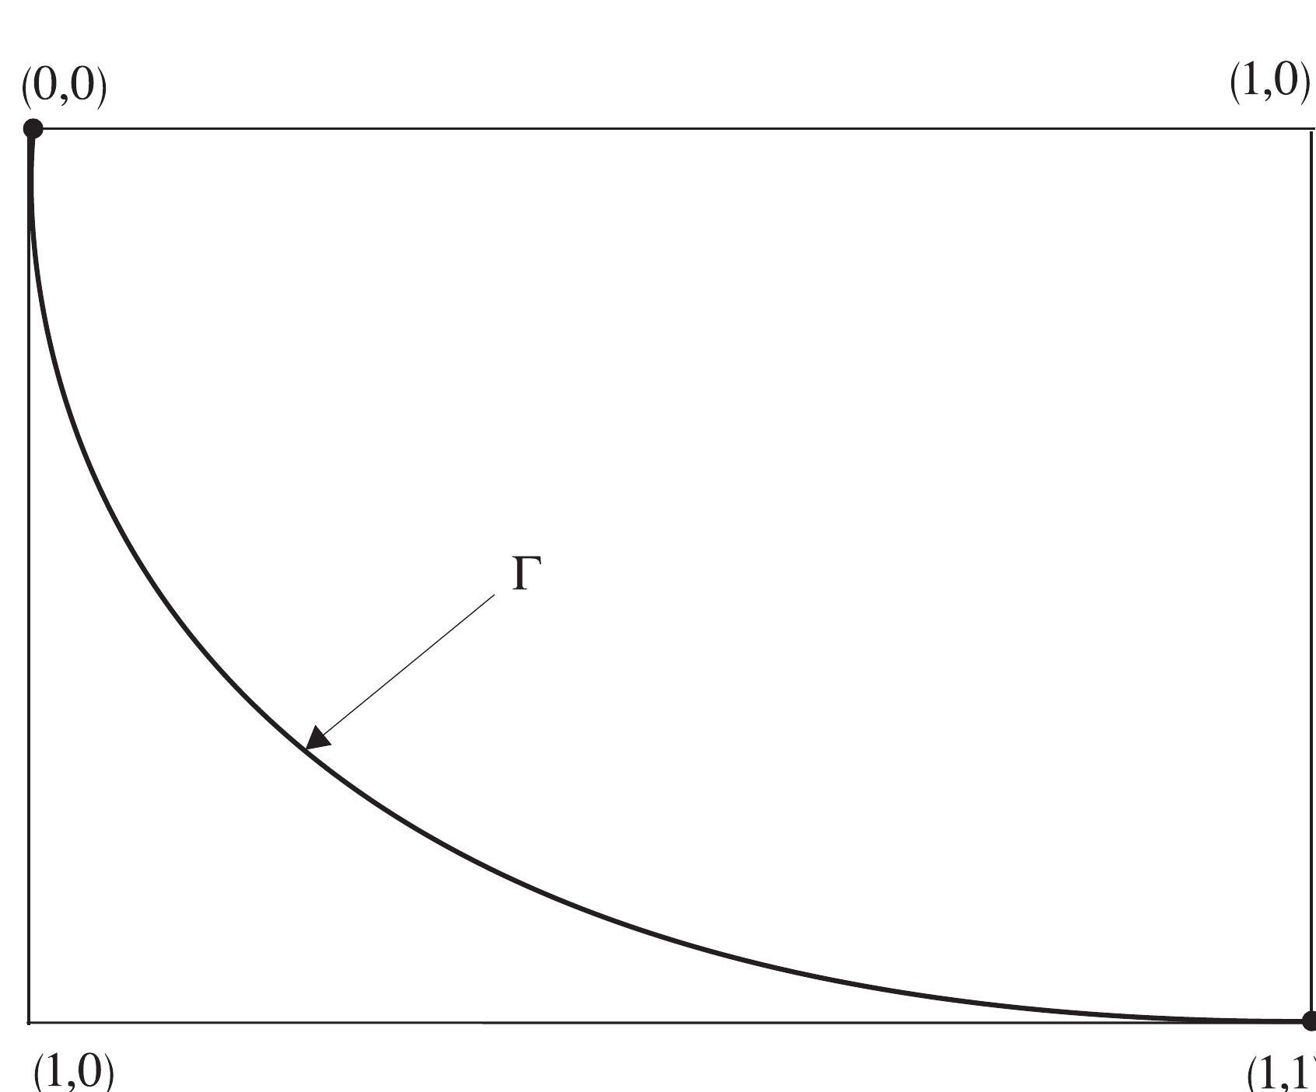
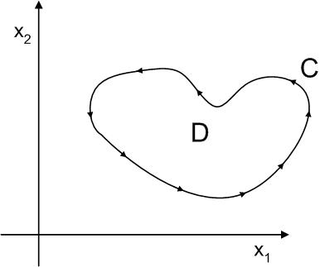
A Simple Restricted Path is a simple path obtained by applying restrictions to a larger geometric path.
Restrictions can include:
$$x≥0 \\ 0≤t≤1$$
or:
$$P∈R$$
where $R$is a specified region.
Example
A complete circle is restricted to its upper semicircle:
$$x^{2}+y^{2}=r^{2}, y≥0$$
The resulting path is simple and open if its two endpoints are treated as distinct endpoints of the arc.

17. Simple Spiral Path
# Source: AI Source: Provided by: [Data Path: Persons Table -> ID Column: 1, Name_En Column: Motasem Essam] -> From: [ChatGPT] on [7/25/2026]
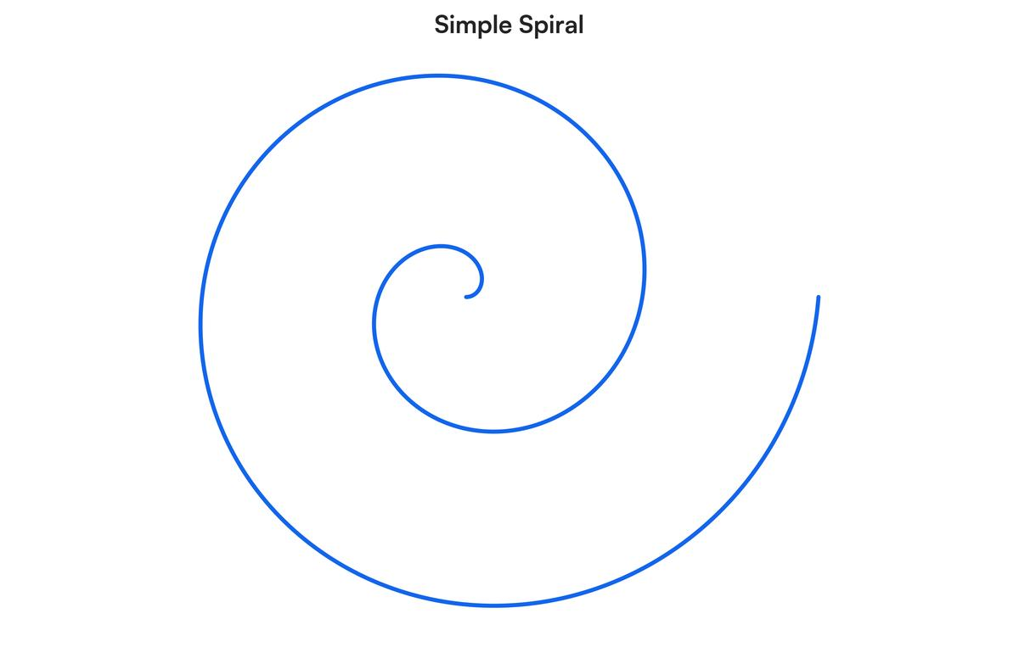
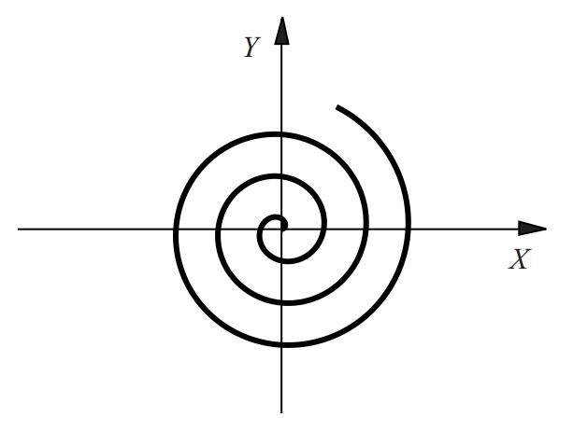
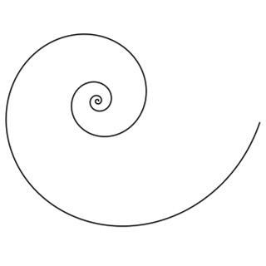
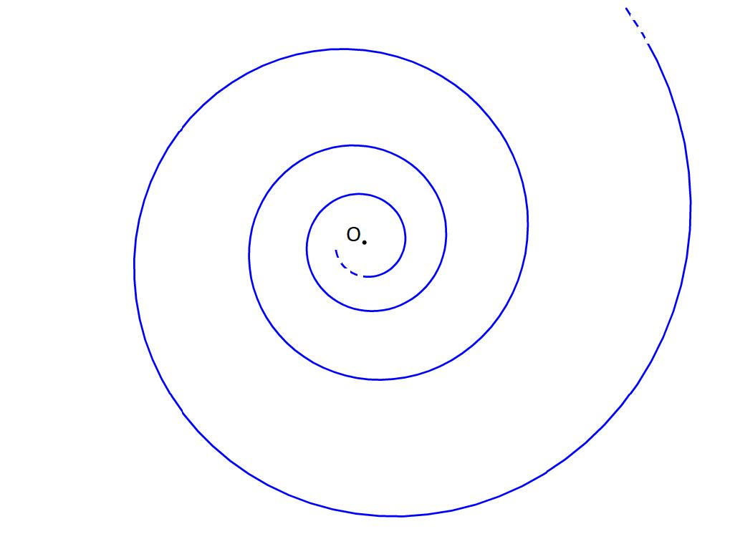
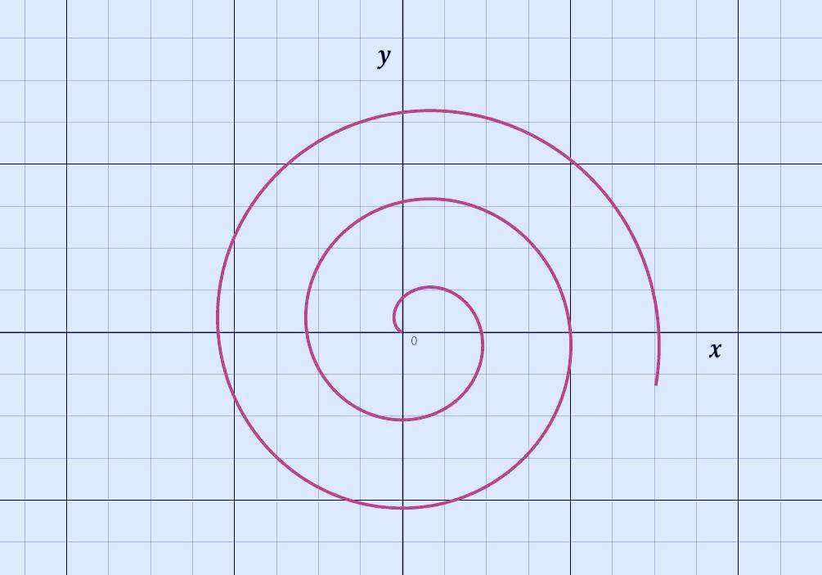
A Simple Spiral Path follows a spiral without crossing itself.
For example, an Archimedean spiral can be written as:
$$r=a+bθ$$
or parametrically:
$$x=\left(a+bθ\right)\cos{θ} \\ y=\left(a+bθ\right)\sin{θ}$$
over a suitable restricted interval.
Example
A single turn of a spiral can be a simple open path.

18. Simple Arc Path
# Source: AI Source: Provided by: [Data Path: Persons Table -> ID Column: 1, Name_En Column: Motasem Essam] -> From: [ChatGPT] on [7/25/2026]
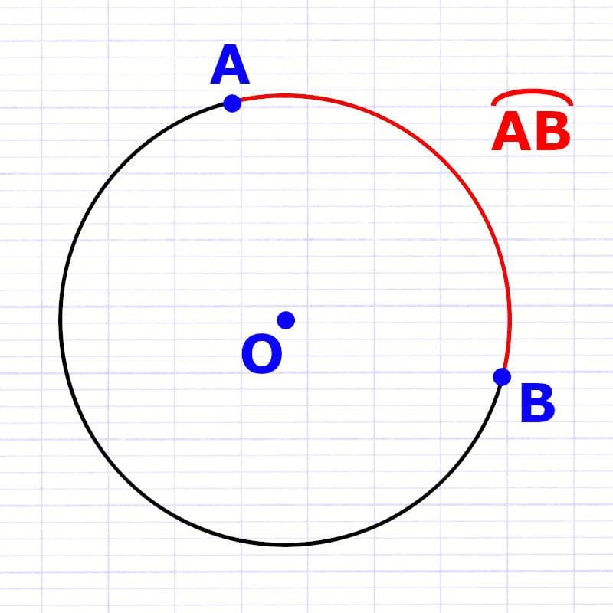
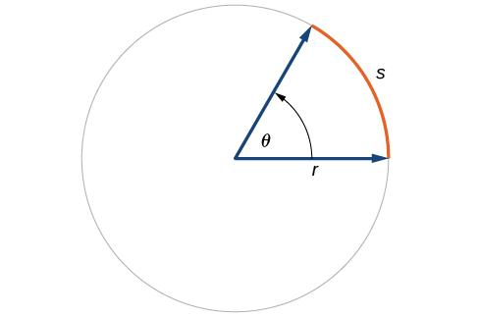
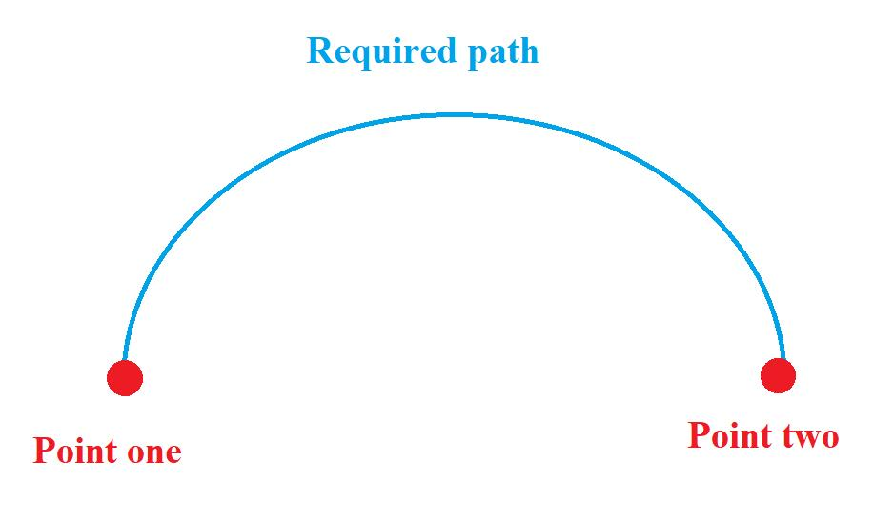
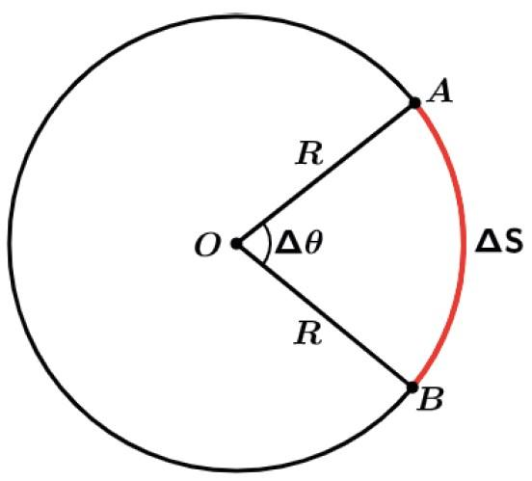
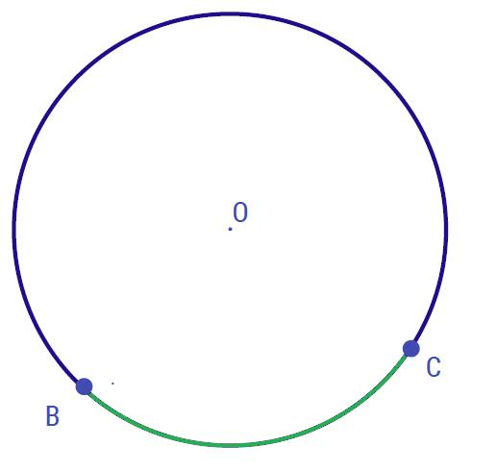
A Simple Arc Path is a portion of a curve that does not intersect itself.
For a circular arc:
$$s=rθ$$
where $θ$is measured in radians.
Example
A quarter-circle from $A$to $B$is a simple arc path.

19. Simple Combined Path
# Source: AI Source: Provided by: [Data Path: Persons Table -> ID Column: 1, Name_En Column: Motasem Essam] -> From: [ChatGPT] on [7/25/2026]
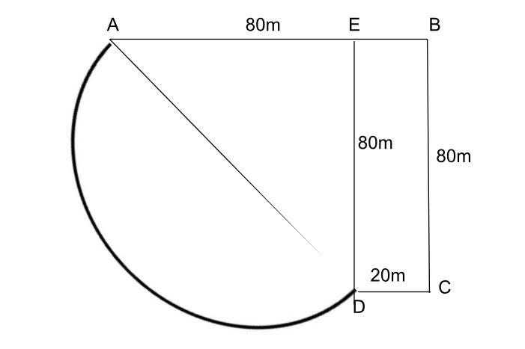
A Simple Combined Path contains different types of geometric pieces but has no self-intersections.
For example:
$$\boxed{\text{Straight}→\text{Circular Arc}→\text{Straight}}$$
can form a simple combined path.
This is common in:
- road design
- robotics
- transportation
- engineering
- computer graphics
- motion planning

Mathematical Definition of Simplicity
# Source: AI Source: Provided by: [Data Path: Persons Table -> ID Column: 1, Name_En Column: Motasem Essam] -> From: [ChatGPT] on [7/25/2026]
For a parameterized path
$$r:\left[a , b\right]→R^{2}$$
the path is simple if:
$$\boxed{r\left(t_{1}\right)=r\left(t_{2}\right)⇒t_{1}=t_{2}}$$
for an open path.
For a closed path, the endpoints are allowed to coincide:
$$\boxed{r\left(a\right)=r\left(b\right)}$$
but for all other parameter values:
$$\boxed{r\left(t_{1}\right)=r\left(t_{2}\right)⇒t_{1}=t_{2}}$$
unless $\left\{t_{1} , t_{2}\right\}=\left\{a , b\right\}$.

Simple Path vs Self-Intersecting Path
# Source: AI Source: Provided by: [Data Path: Persons Table -> ID Column: 1, Name_En Column: Motasem Essam] -> From: [ChatGPT] on [7/25/2026]
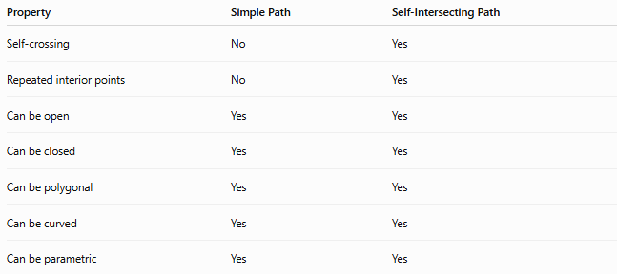
Property | Simple Path | Self-Intersecting Path
Self-crossing | No | Yes
Repeated interior points | No | Yes
Can be open | Yes | Yes
Can be closed | Yes | Yes
Can be polygonal | Yes | Yes
Can be curved | Yes | Yes
Can be parametric | Yes | Yes
The fundamental distinction is:
$$\boxed{\text{Simple}=\text{No Self-Intersection}}$$

Simple Path vs Open Path vs Closed Path
# Source: AI Source: Provided by: [Data Path: Persons Table -> ID Column: 1, Name_En Column: Motasem Essam] -> From: [ChatGPT] on [7/25/2026]
These classifications describe different properties.
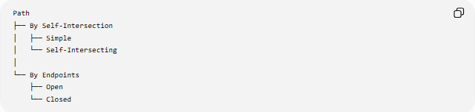
Path
├── By Self-Intersection
│ ├── Simple
│ └── Self-Intersecting
│
└── By Endpoints
├── Open
└── Closed
Therefore, a path can be:
- simple and open
- simple and closed
- self-intersecting and open
- self-intersecting and closed
For example:
$$\boxed{\text{Simple Closed Path}}$$
is a valid combination.

Simple Path vs Smooth Path
# Source: AI Source: Provided by: [Data Path: Persons Table -> ID Column: 1, Name_En Column: Motasem Essam] -> From: [ChatGPT] on [7/25/2026]
Simple concerns self-intersection.
Smooth concerns differentiability/tangent behavior.
Therefore they are independent properties.
A path can be:
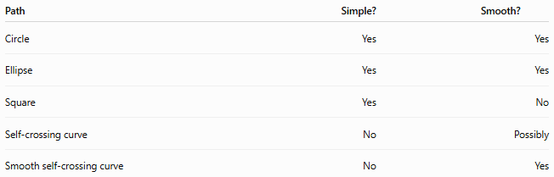
Path | Simple? | Smooth?
Circle | Yes | Yes
Ellipse | Yes | Yes
Square | Yes | No
Self-crossing curve | No | Possibly
Smooth self-crossing curve | No | Yes
Thus:
$$\boxed{\text{Simple}⇏\text{Smooth}}$$
and:
$$\boxed{\text{Smooth}⇏\text{Simple}}$$

Simple Path vs Polygonal Path
# Source: AI Source: Provided by: [Data Path: Persons Table -> ID Column: 1, Name_En Column: Motasem Essam] -> From: [ChatGPT] on [7/25/2026]
A Polygonal Path describes the geometry of the path: it consists of straight segments.
A Simple Path describes whether the path self-intersects.
Therefore:
$$\boxed{\text{Simple Polygonal Path}}$$
is a combination of two properties.
A polygonal path can be either:
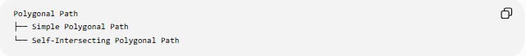
Polygonal Path
├── Simple Polygonal Path
└── Self-Intersecting Polygonal Path

Simple Path and Topology
# Source: AI Source: Provided by: [Data Path: Persons Table -> ID Column: 1, Name_En Column: Motasem Essam] -> From: [ChatGPT] on [7/25/2026]
In topology and mathematical analysis, a simple path is often called a simple arc when it is an injective continuous image of an interval.
For a continuous parameterization:
$$r:\left[a , b\right]→R^{n}$$
simplicity means that distinct parameter values do not map to the same point, except possibly $a$and $b$for a simple closed curve.
This makes simplicity important in:
- topology
- computational geometry
- graph geometry
- curve theory
- geometric modeling

Length of a Simple Path
# Source: AI Source: Provided by: [Data Path: Persons Table -> ID Column: 1, Name_En Column: Motasem Essam] -> From: [ChatGPT] on [7/25/2026]
Simplicity does not determine the length.
For a parametric path:
$$\boxed{L=\int_{a}^{b}{\sqrt{{\left(x^{'}\left(t\right)\right)}^{2}+{\left(y^{'}\left(t\right)\right)}^{2}}} dt}$$
For a polygonal path:
$$\boxed{L=\sum_{i=0}^{n-1}{∣}P_{i}P_{i+1}∣}$$
For two endpoints $A$and $B$:
$$\boxed{L≥AB}$$
with equality only when the path is the straight segment connecting $A$and $B$.

Important Geometric Relationships
# Source: AI Source: Provided by: [Data Path: Persons Table -> ID Column: 1, Name_En Column: Motasem Essam] -> From: [ChatGPT] on [7/25/2026]
Simple + Open
$$\boxed{P_{s}≠P_{e} \text{and no self-intersection}}$$
Simple + Closed
$$\boxed{P_{s}=P_{e} \text{and no other self-intersection}}$$
Simple + Smooth
$$\boxed{\text{No self-intersection + continuous tangent behavior}}$$
Simple + Convex
$$\boxed{\text{No self-intersection + convex enclosed region}}$$
Simple + Polygonal
$$\boxed{\text{No self-intersection + straight-line pieces}}$$

Classification Summary
# Source: AI Source: Provided by: [Data Path: Persons Table -> ID Column: 1, Name_En Column: Motasem Essam] -> From: [ChatGPT] on [7/25/2026]
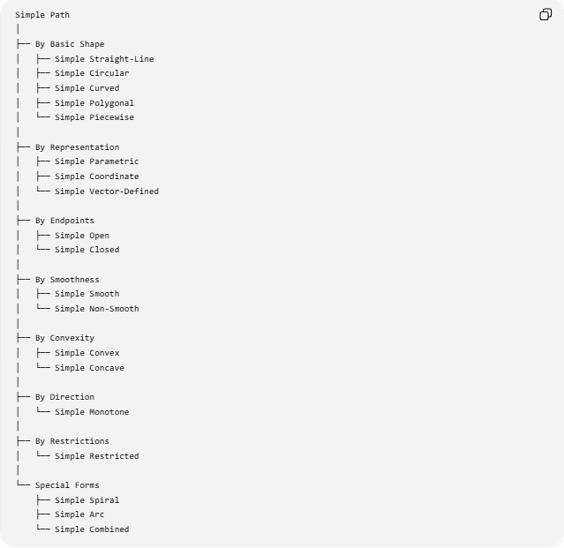
Simple Path
│
├── By Basic Shape
│ ├── Simple Straight-Line
│ ├── Simple Circular
│ ├── Simple Curved
│ ├── Simple Polygonal
│ └── Simple Piecewise
│
├── By Representation
│ ├── Simple Parametric
│ ├── Simple Coordinate
│ └── Simple Vector-Defined
│
├── By Endpoints
│ ├── Simple Open
│ └── Simple Closed
│
├── By Smoothness
│ ├── Simple Smooth
│ └── Simple Non-Smooth
│
├── By Convexity
│ ├── Simple Convex
│ └── Simple Concave
│
├── By Direction
│ └── Simple Monotone
│
├── By Restrictions
│ └── Simple Restricted
│
└── Special Forms
├── Simple Spiral
├── Simple Arc
└── Simple Combined

Key Formulas
# Source: AI Source: Provided by: [Data Path: Persons Table -> ID Column: 1, Name_En Column: Motasem Essam] -> From: [ChatGPT] on [7/25/2026]
Fundamental Simplicity Condition
$$\boxed{r\left(t_{1}\right)=r\left(t_{2}\right)⇒t_{1}=t_{2}}$$
except for the permitted initial/final equality of a closed path.
Open Path
$$\boxed{P_{s}≠P_{e}}$$
Closed Path
$$\boxed{P_{s}=P_{e}}$$
Parametric Representation
$$\boxed{r\left(t\right)=\left\langle x , \left(t\right)y\left(t\right)\right\rangle }$$
Parametric Length
$$\boxed{L=\int_{a}^{b}{\sqrt{{\left(x^{'}\right)}^{2}+{\left(y^{'}\right)}^{2}}} dt}$$
Polygonal Length
$$\boxed{L=\sum_{i=0}^{n-1}{∣}P_{i}P_{i+1}∣}$$
Straight-Line Distance
$$\boxed{AB=\sqrt{{\left(x_{B}-x_{A}\right)}^{2}+{\left(y_{B}-y_{A}\right)}^{2}}}$$

Key Points
# Source: AI Source: Provided by: [Data Path: Persons Table -> ID Column: 1, Name_En Column: Motasem Essam] -> From: [ChatGPT] on [7/25/2026]
- A Simple Path does not self-intersect.
- Simplicity is primarily a condition concerning self-intersection.
- A simple path can be open or closed.
- A simple path can be straight, circular, curved, polygonal, or piecewise.
- A simple path does not necessarily have to be smooth.
- A simple path does not necessarily have to be convex.
- A square is a simple closed non-smooth path.
- A circle is a simple closed smooth path.
- A non-crossing polygon is a simple polygonal path.
- A self-crossing path is not simple.
- A closed path can be simple even though its start and end coincide.
- Simplicity and smoothness are different properties.
- Simplicity and convexity are different properties.
- Simplicity can be combined with other path classifications.
- In parameterized geometry, simplicity is closely related to injectivity.

Conclusion
# Source: AI Source: Provided by: [Data Path: Persons Table -> ID Column: 1, Name_En Column: Motasem Essam] -> From: [ChatGPT] on [7/25/2026]
A Simple Path is a path that does not intersect itself, with the special allowance that a closed path may return to its starting point.
Its fundamental condition is:
$$\boxed{\text{No self-intersection}}$$
For an open parameterized path:
$$\boxed{r\left(t_{1}\right)=r\left(t_{2}\right)⇒t_{1}=t_{2}}$$
while a simple closed path additionally satisfies:
$$\boxed{r\left(a\right)=r\left(b\right)}$$
Simple paths can take many forms, including straight-line, circular, curved, polygonal, piecewise, parametric, open, closed, smooth, non-smooth, convex, and concave paths.
The most important distinction is:
$$\boxed{\text{Simple Path}≠\text{Open Path}≠\text{Closed Path}}$$
because simple describes self-intersection, while open/closed describes the relationship between the starting and ending points.

